12 May 2024

Machine Learning

Prof. Dina khatab

[Doctor Fee Prediction]

Milestone 1

# Team

AI_R_1

Nour sameh 2021170885

Nour madkour 2021170884

Rawan badr 2021170863

Menna maged 2021170875

Hoor hesham 2021170861

### Data Overview

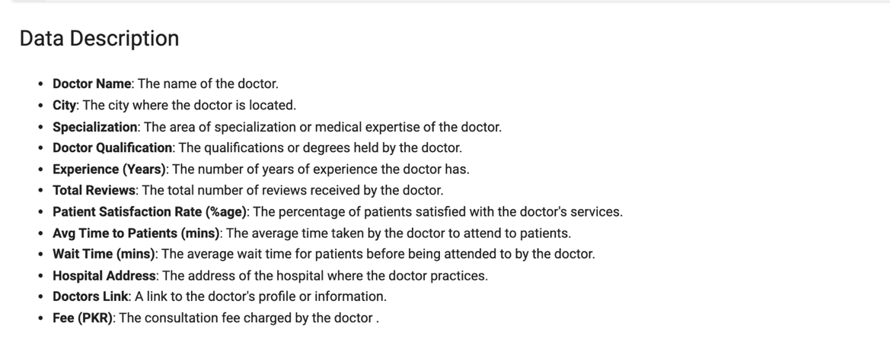

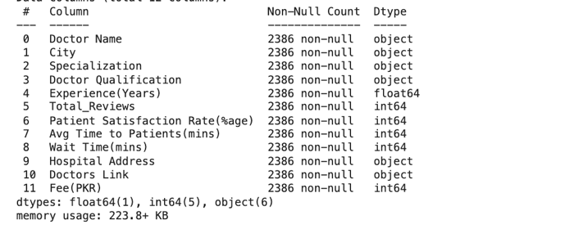

1.No null values but there may be missing values

2.data need to be encoded "Doctor Name" , "City", "Specialization" ,

"Doctor Qualification" ,"Hospital Address", "Doctors Link"

3. dropped duplicated values

4. Statistics for categorical columns.

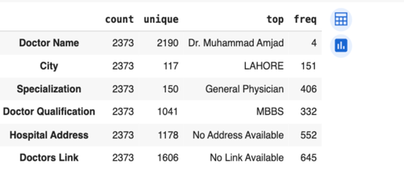

found out that most freq in these 2 cols 'Hospital Address' & 'Doctors Link ' No Address Available & No Link Available So we may drop them and may not

5. Renamed columns to manipulate on the easily

**Table of content**

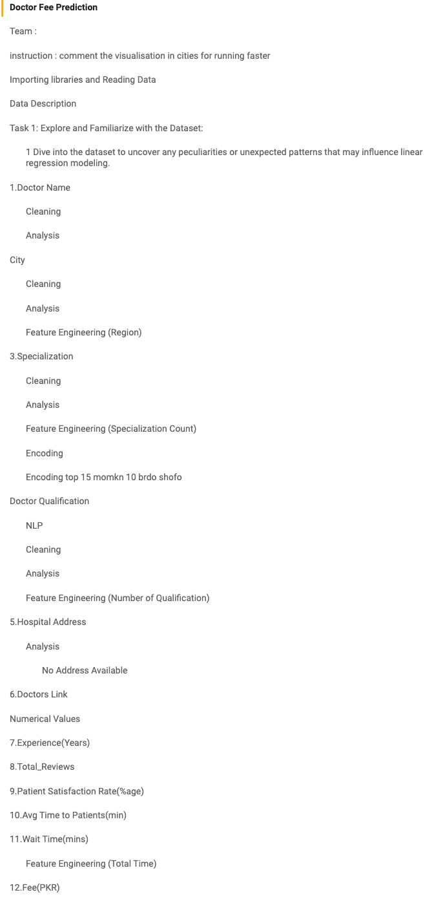

# **1.Doctor Name**

1.1 **Cleaning**

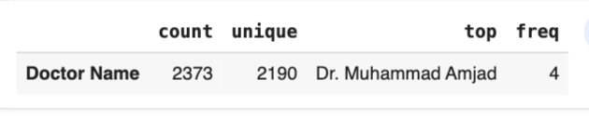

1.saw duplicates

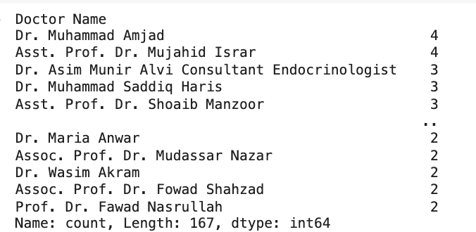

2. saw freq of the repeated drs

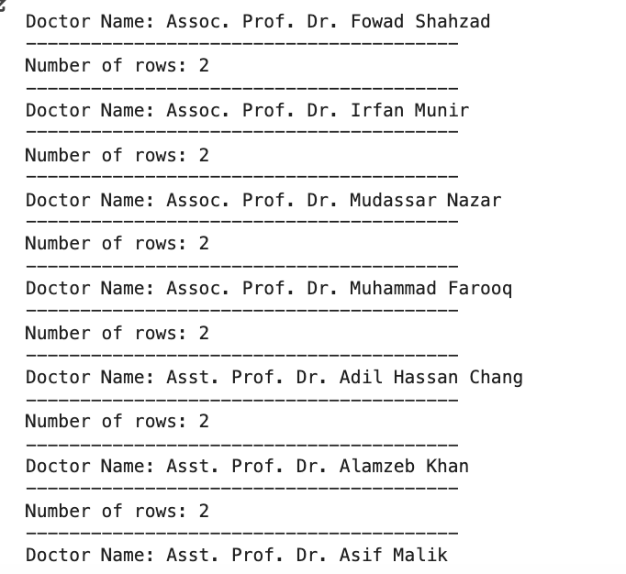

Most from 2-4 repitition

the duplicated names maybe Similarity of names we will see that when see more relation with other columns like 'Link' , ‘City’, ‘Specialization’(refer to 1.2 in Dr names number(5))

1.2 **Feature engnieering split (Doctor Names)To (Titles), (Names)**

3. extract_titles_and_name

4. find_empty_title_rows

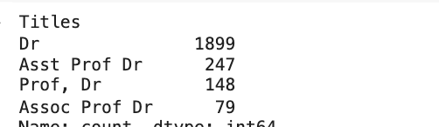

If not from these added to unique value ‘others’

5. 1st refered to dropped rows of dr that have same ['Doctor Name', 'Specialization','City'] and also 'Doctors Link' as it is wierd to have dr have same all things(80 rows)

1.3 Analysis

1

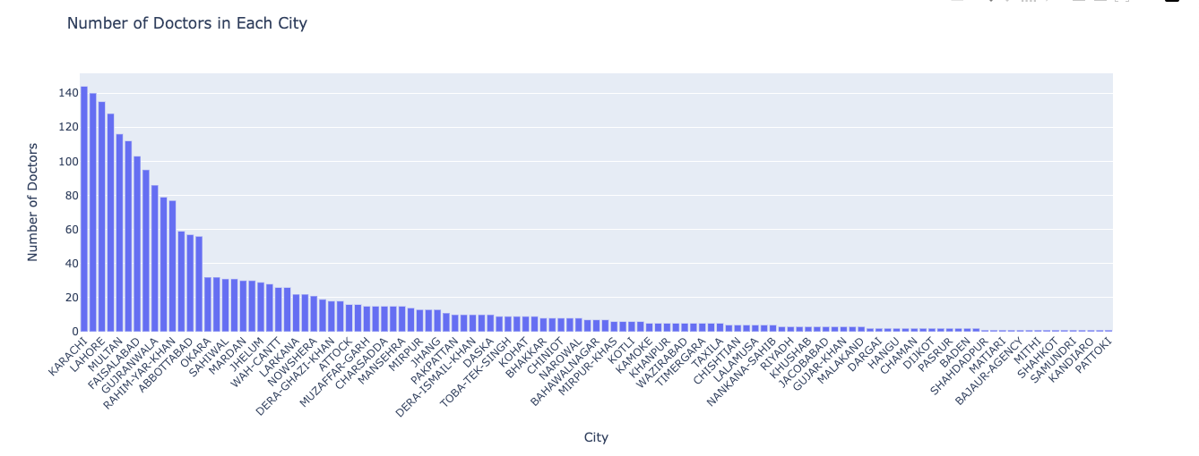

In conclusion, the analysis reveals that Karachi has the highest number of doctors compared to other cities in the dataset. However, it's worth noting that several cities have only one doctor listed. This discrepancy in the distribution of doctors across cities might indicate variations in healthcare accessibility and resource allocation.

2.

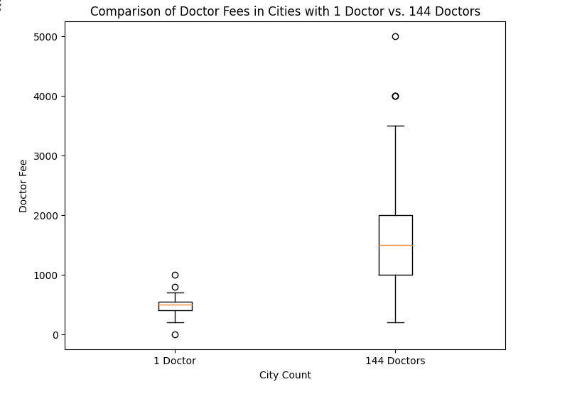

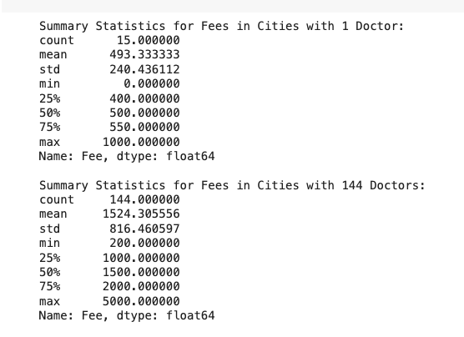

Cities with 1 doctor have a fee range from 0 to 1000, whereas cities with 144 doctors have a wider fee range from $200 to 5000 This indicates greater variability in the fees charged by doctors in cities with a higher concentration of doctors.

avg comparing

In cities with only 1 doctor, the mean fee charged is significantly lower at approximately 493.33 compared to cities with 144 doctors, where the mean fee is substantially higher at approximately 1524.31. This suggests that there is a noticeable difference in the average fees depending on the number of doctors in a city.

# **2.City**

2.1 **Cleaning**

1.Removed ‘-’ and made city lower case in order to see if there is any repeated city

2.2 **Analysis**

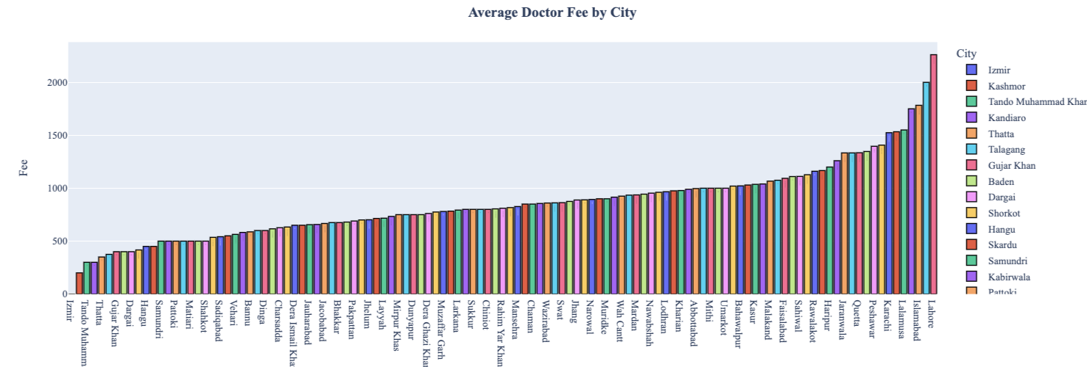

2. the avg fees are in LAHORE city lets dive into it and see fees of drs in this city , whilr in IZMIR is the lowes avg tends to 0

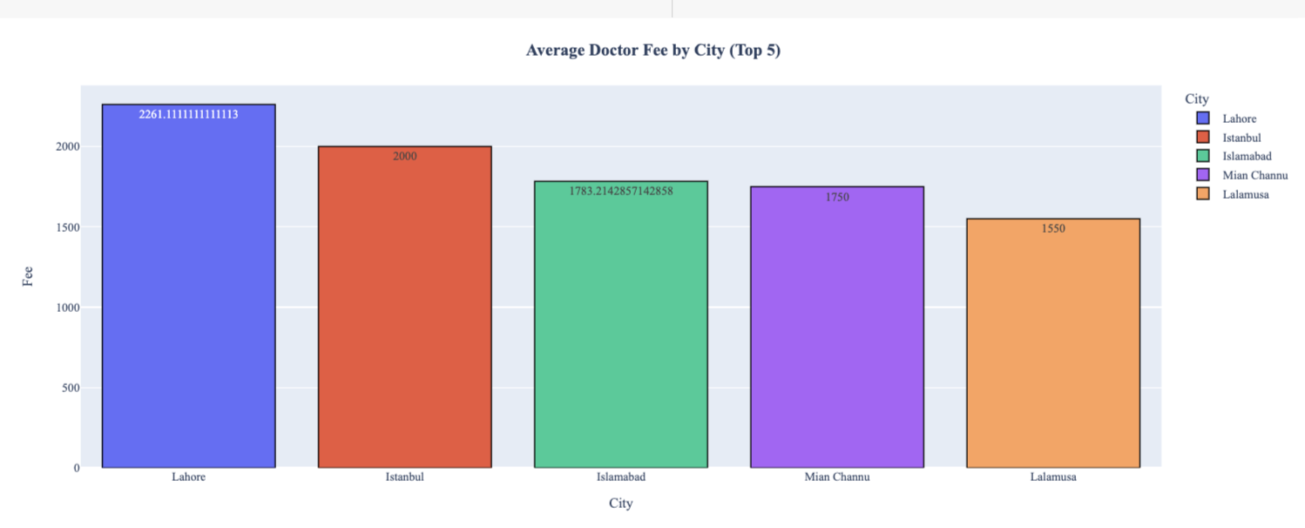

3.The fees vary considerable, with a standard deviation of approximately 1369.37, suggesting a wide range of fee amounts.

4. The city with the minimum average fees is Izmir with an average fee of $0.00.



5. this suggest that this dr giving charity for ppl as it is free for (Eye Surgeon) **Patient_Satisfaction_Rate is 94**

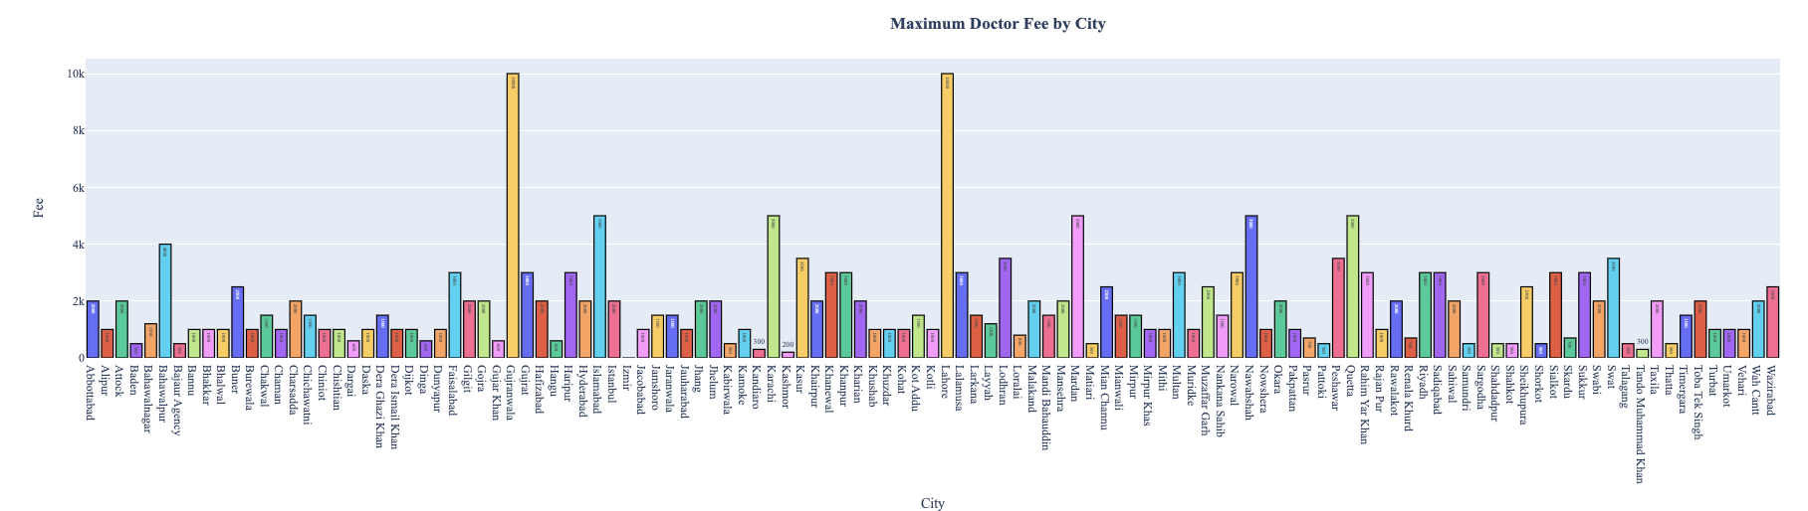

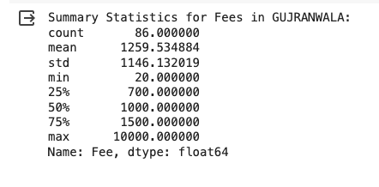

a wide range of fees charged by doctors in the city, with a minimum fee of 20 and a maximum fee of 10,000. The mean fee of approximately 1259.53 indicates the average cost of medical services

(IQR) of 800 (from 700 to 1500) suggests that the middle 50% of fees are relatively consistent, with the median fee (1000) falling within this range. This indicates that while there is considerable variability in fees, **a significant portion of doctors charge fees within a certain range**

## 2.3 Feature Engineering (Region)

Used folium library to see correlation between cities and desided to devide it to 6 regions

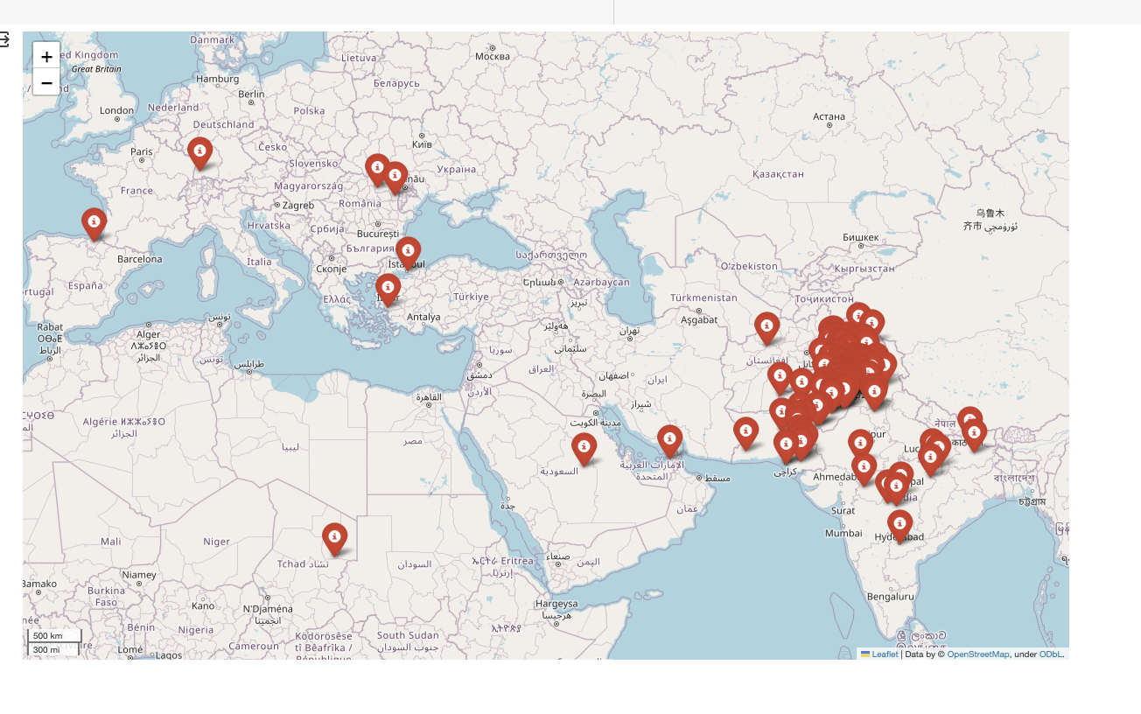

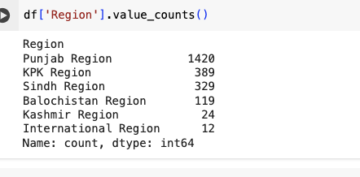

# **3.Specialization**

2.1 **Cleaning**

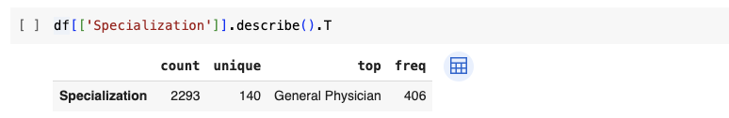

1.Processed specialization to remove redundant values

from tabulate import tabulate

Captured more typos and mapped the corrected once

specialization_mapping = {

"Pediatrician,Pediatric": "Pediatrician",

"Lung Specialist": "Pulmonologist",

"Eye Surgeon,Eye Specialist": "Ophthalmologist",

"Sexologist": "Andrologist",

"Cosmetic Surgeon,Dermatologist": "Cosmetic Dermatologist",

"Internal Medicine Specialist,General Physician,Infectious Diseases": "Infectious Disease Specialist",

}

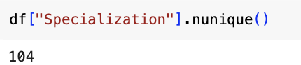

Went from 140 to 128 and that’s good

2.2 **Analysis**

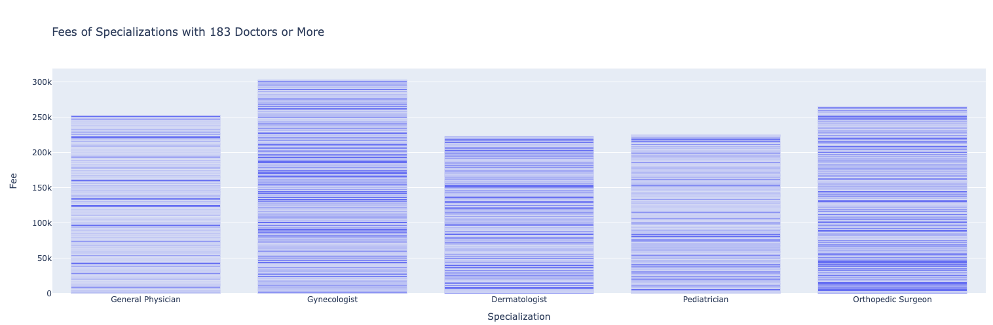

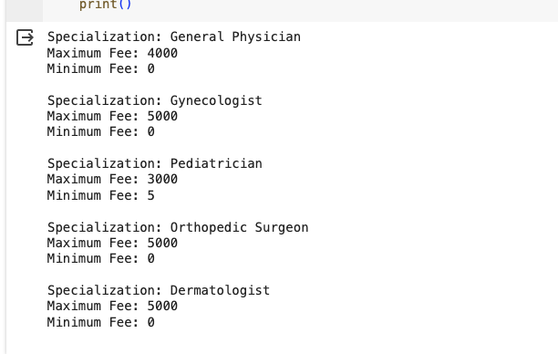

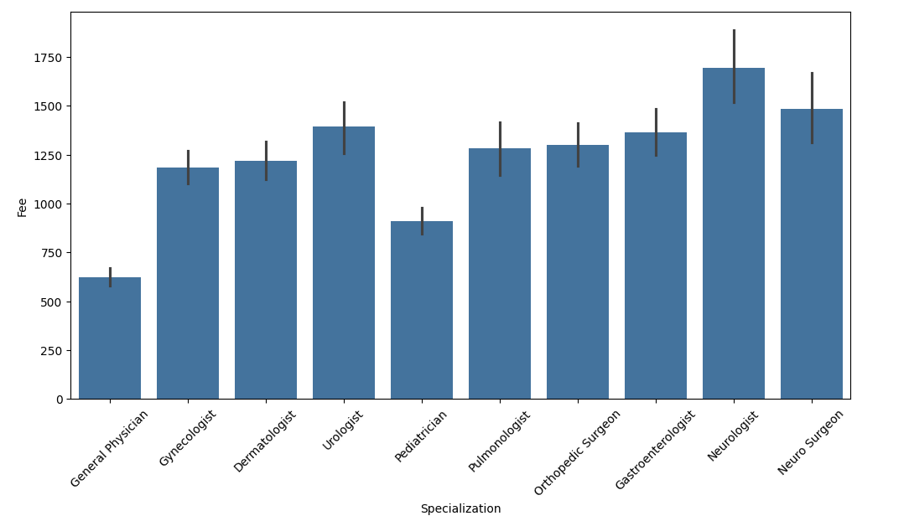

Drs with less experiene have highest rating and dr that are 47 yrs are not given a rate

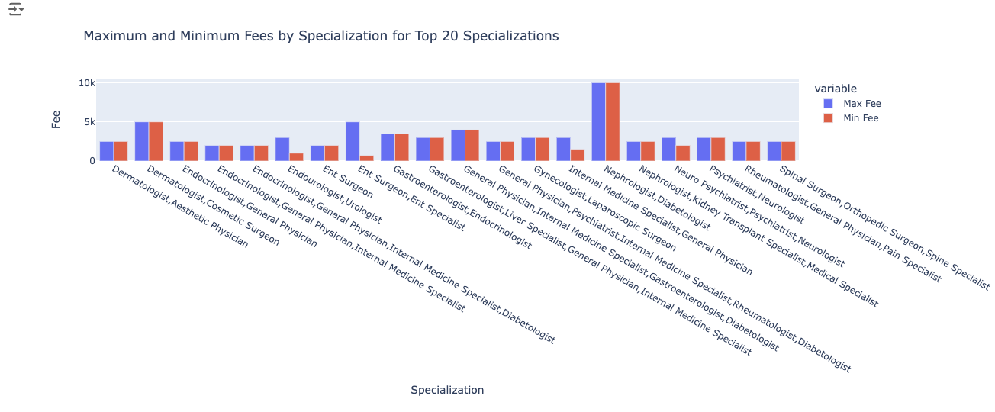

Nephrologist,Diabetologist apears to have same max and min fees so lets view it

## 3.3 Feature Engineering (Specialization Count)

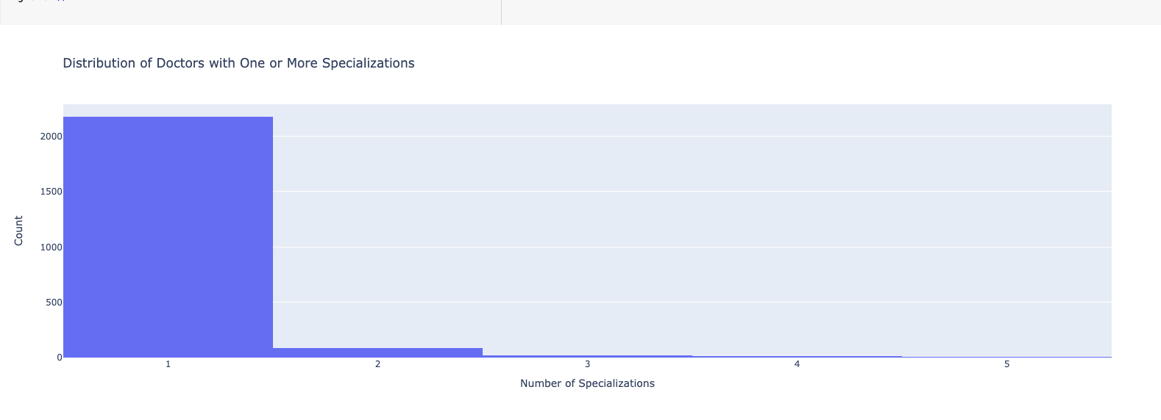

1 . Most drs have 1 or 2 specialization

Number of Dr with multiple specializations: 118

3. Maximum number of specializations: 5

Minimum number of specializations:1

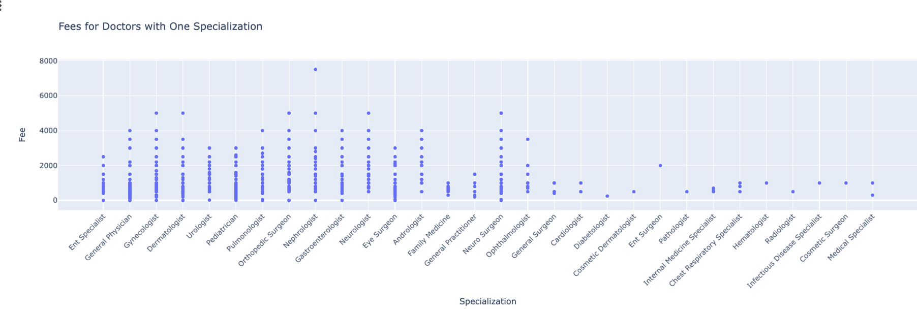

2. fees varies but the Neurologist takes highest fees

4 drs that have 1 or 2 specialization are the most ppl that take higer fees that is expected 3shan e7na bnb2a 3wziin nroo7 to specialized dr not drs for everthing

# 4**.** Doctor Qualification

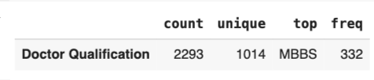

4.1 cleaning

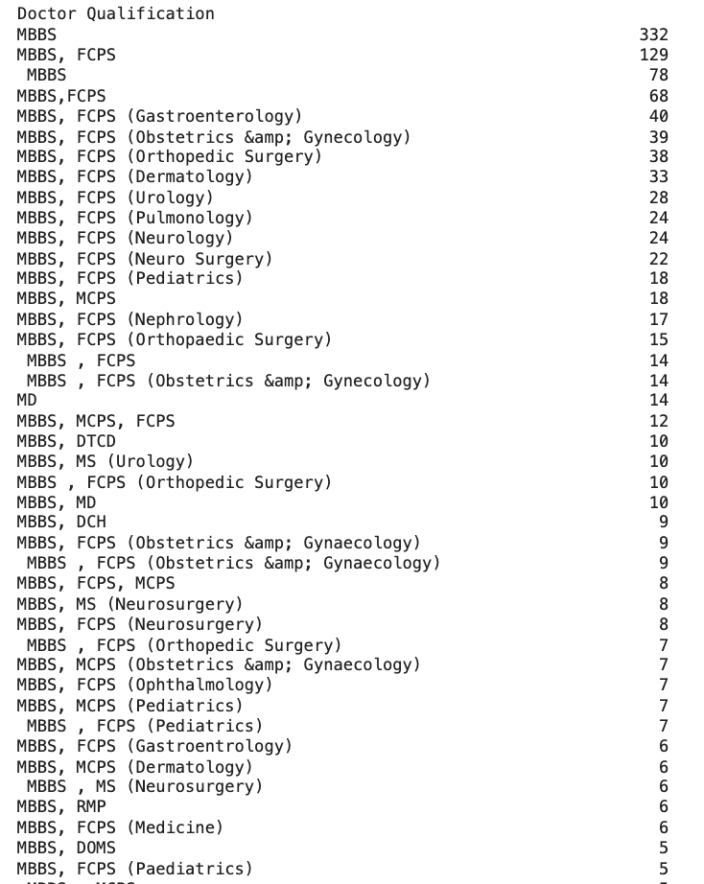

there are typo error so will remove it

Tried nltk gave us 845 unique so prefered to do it manually

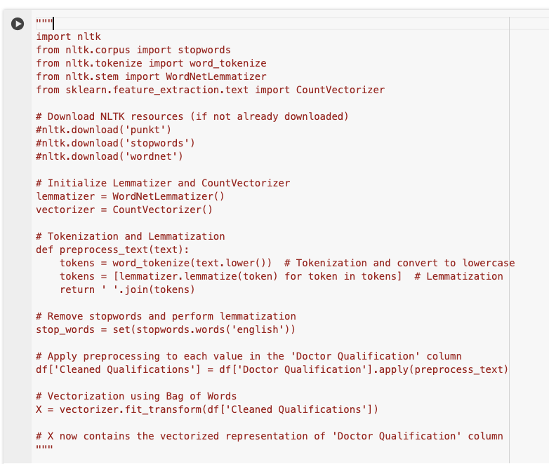

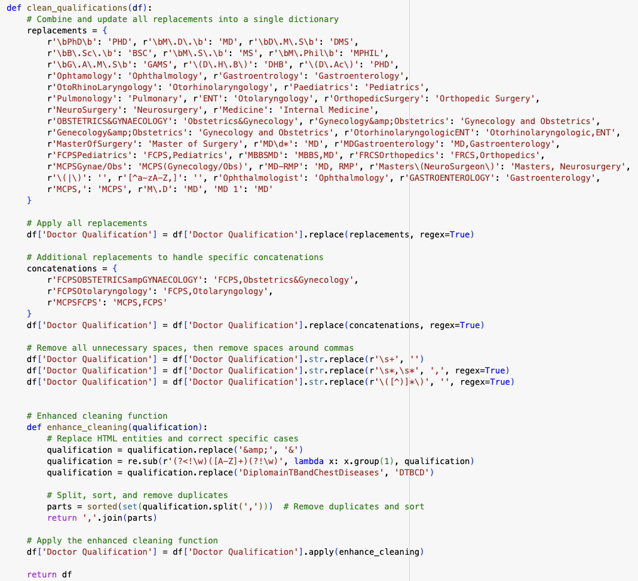

## 826 and that’s better than nltk

## 4.2 Analysis

#drs that dont have mbbs

#conclusion : 89 rows

* 96.2% of the drs have MBBs Qualification
* 3.8 % only dont have MBBs.

most of drs have MBBS (Bachelor of Medicine, Bachelor of Surgery)

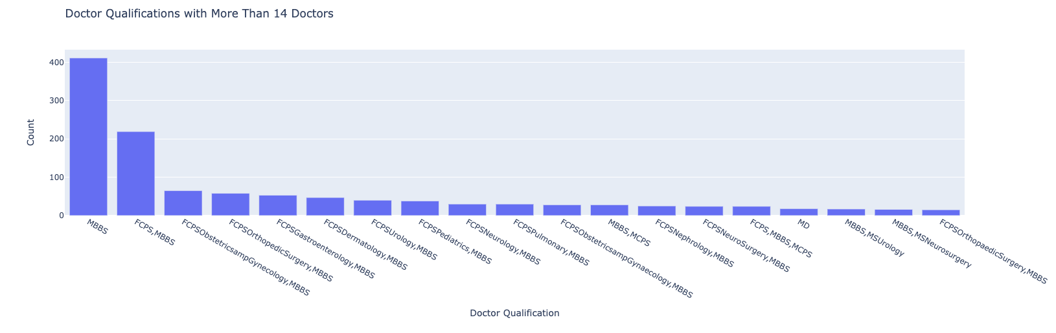

Most drs take this qualifications

Maximum number of qualifications: 11

Minimum number of qualifications: 1

## 4.3 Feature Engineering (Number of Qualification)

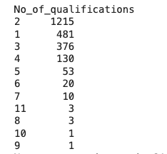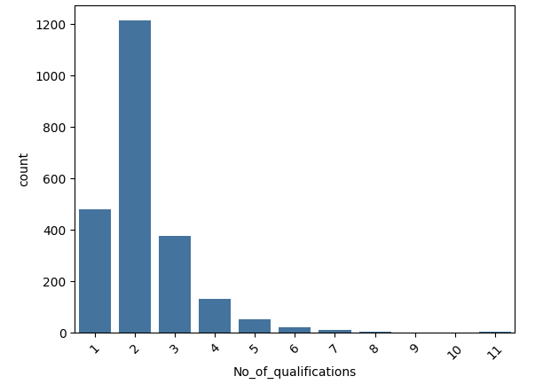

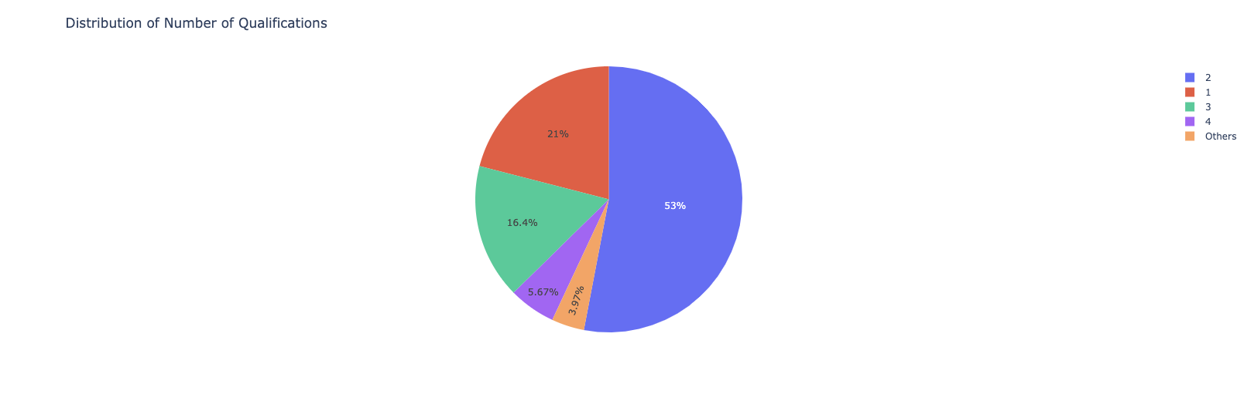

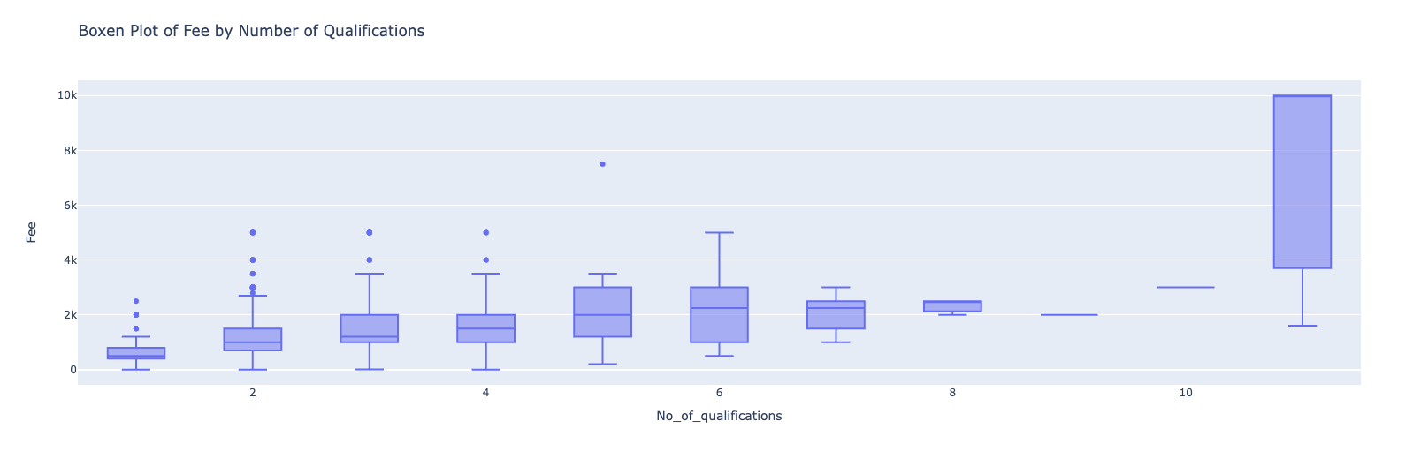

As the number of qualifications of doctors increase, So does there fees increases, but after 8 qualifications fees seem to decrease and then increase at 12

# **5.1 Hospital Address**

# **feature engnieering has_hospital address**

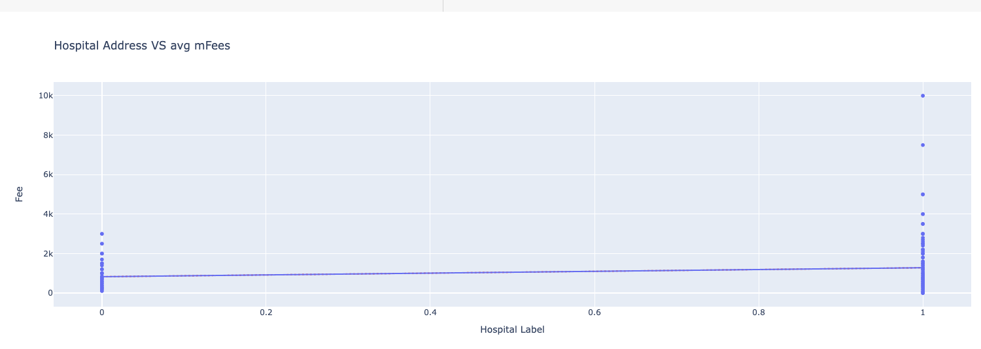

Those who have address seems to be easier to patient to go to so avg fees of drs are more

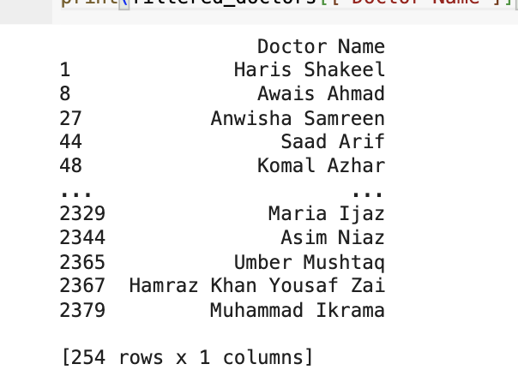

Drs that don’t have both link nor hospital address 254

Wanted to see relation on msno

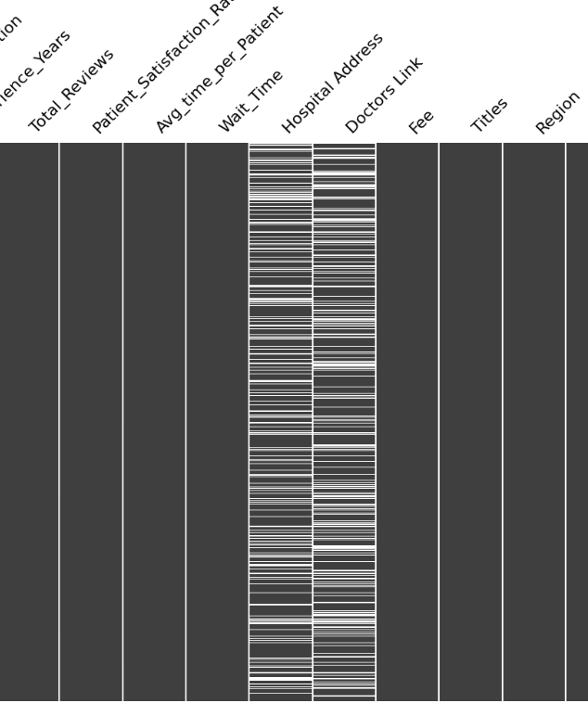

# **5.1 Analysis**

Highest avg fees in Doctors Hospital, Johar Town,Lahore hase the highest avg fees , it appeared 6 times in df

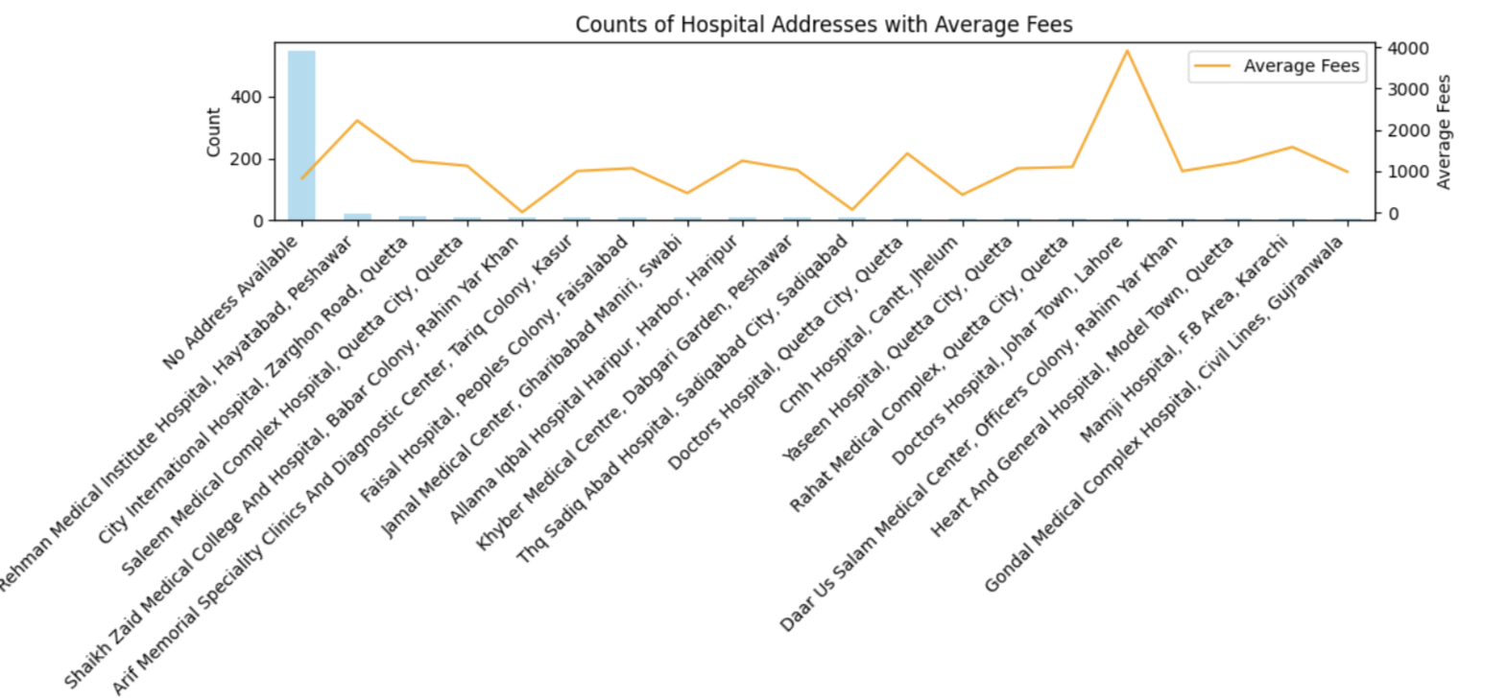

Doctors with the highest fees at Doctors Hospital, Johar Town, Lahore :

Doctor Name Fee

46 Ghazanfar Ali Shah 5000

96 Qurat Ul Ain Sajida 3500

839 Syed Shahzad Hussain Shah 3000

987 Tariq Sohail 4000

1767 Muhammad Bilal 3000

1959 Khurshid Alam 5000

# **6.Doctors Link**

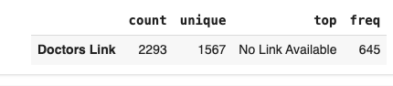

Replaced no link av by homepage df['Doctors Link'] = df['Doctors Link'].replace('No Link Available', 'https://instacare.pk/')

# ****Numerical Values****

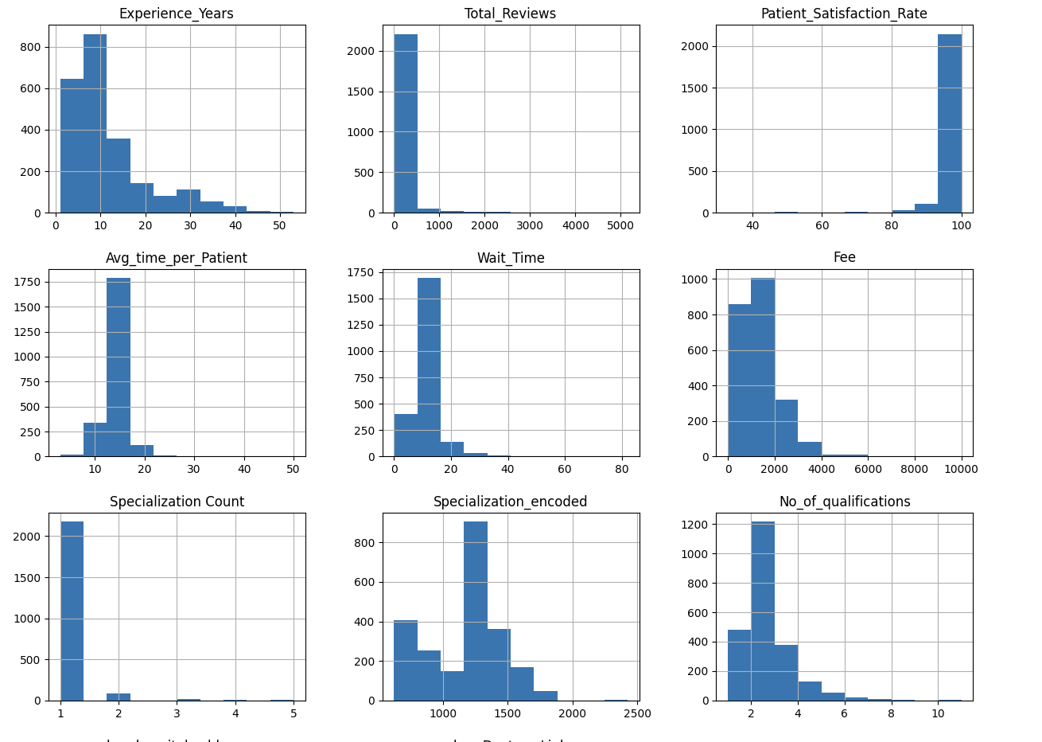

we concluded that

1. experience is somehow normally distributed
2. total_reviews is right skewed and the max is > 2000 & min is almost 0
3. try log to cancel skewness

# **7.Experience(Years)**



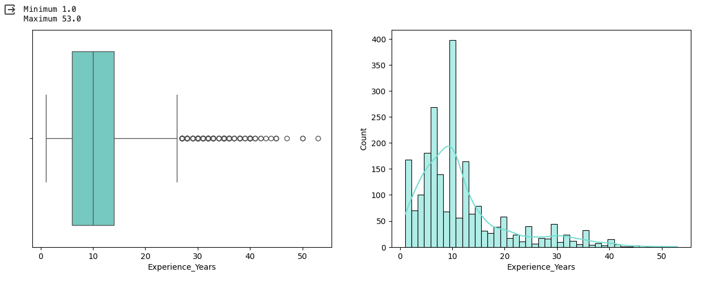

concluded that there are drs that have experience yrs 1.5 and 4.5 so will round them

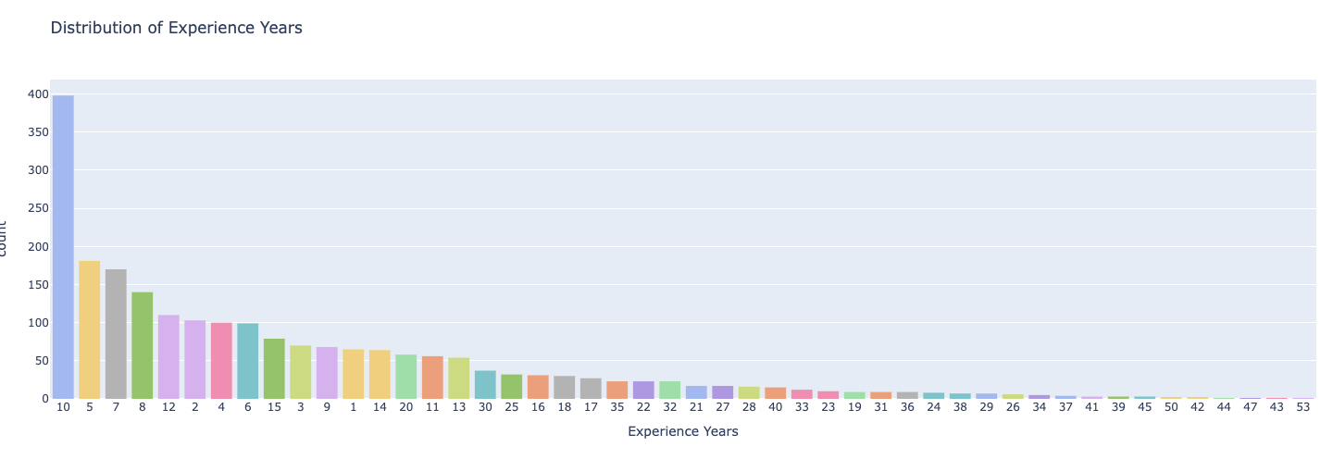

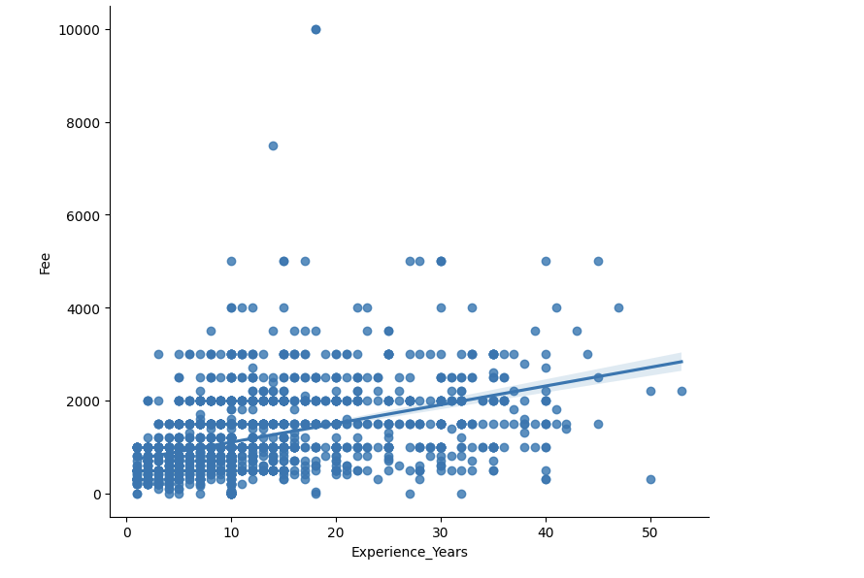

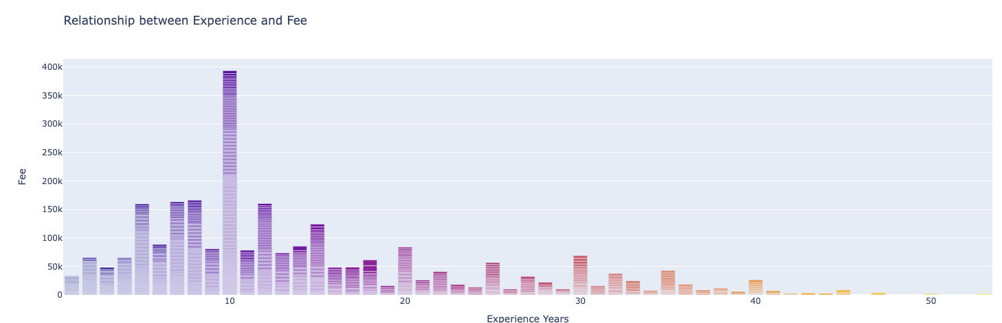

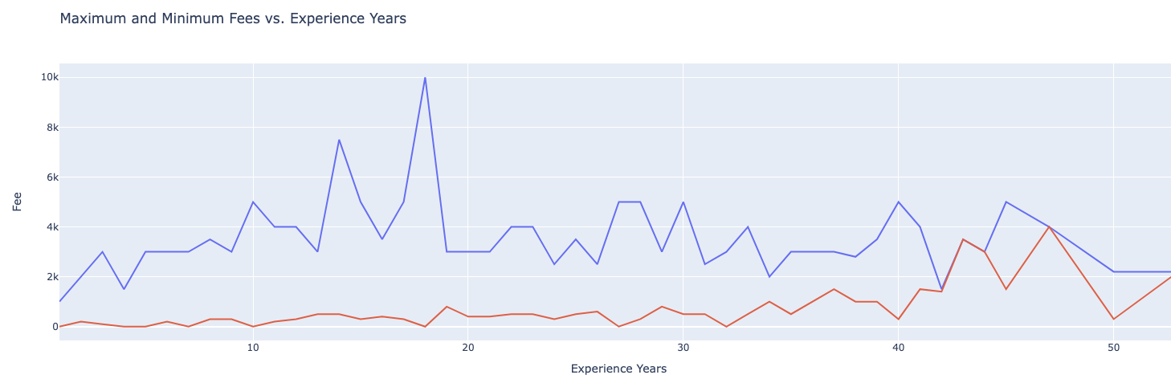

* AT max_fees : wee got that drs with experience 5 or more yrs are maximum then there is a drop at 24yrs then gets high again
* min_fees varies as exp varies to sum us fees is not that related to experience as there is a wide range in fees as it depends more on market demand , specialization ,Patient Demographics

**7.Feature engnieering** (Experience_Group)

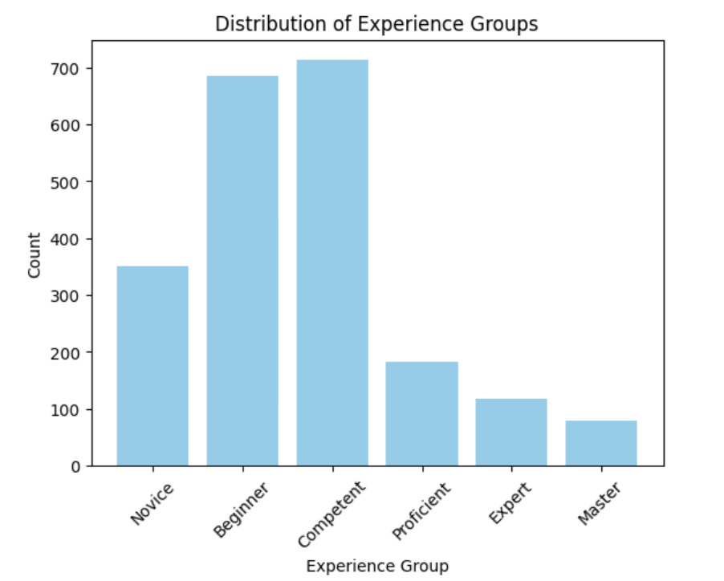

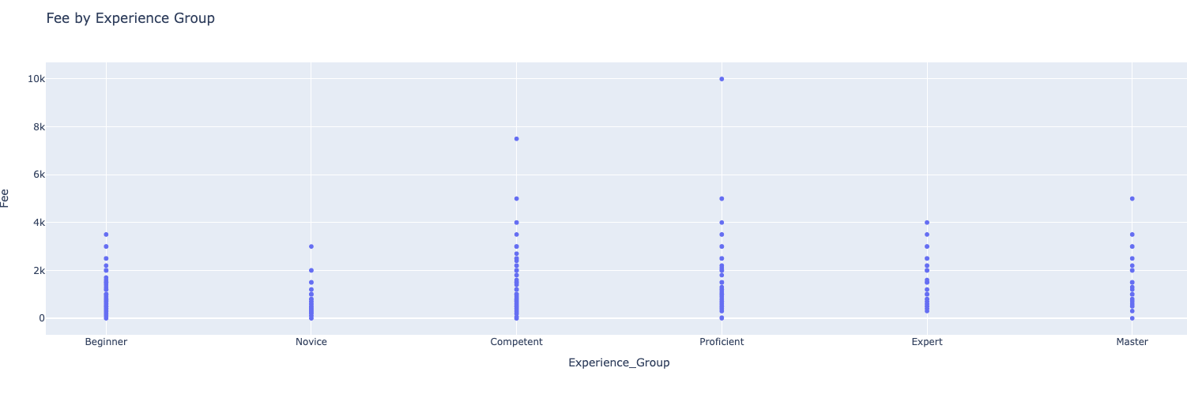

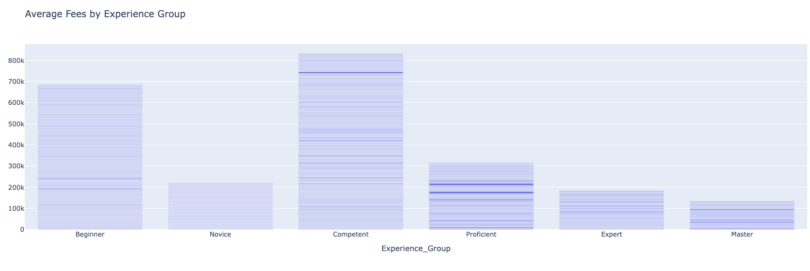

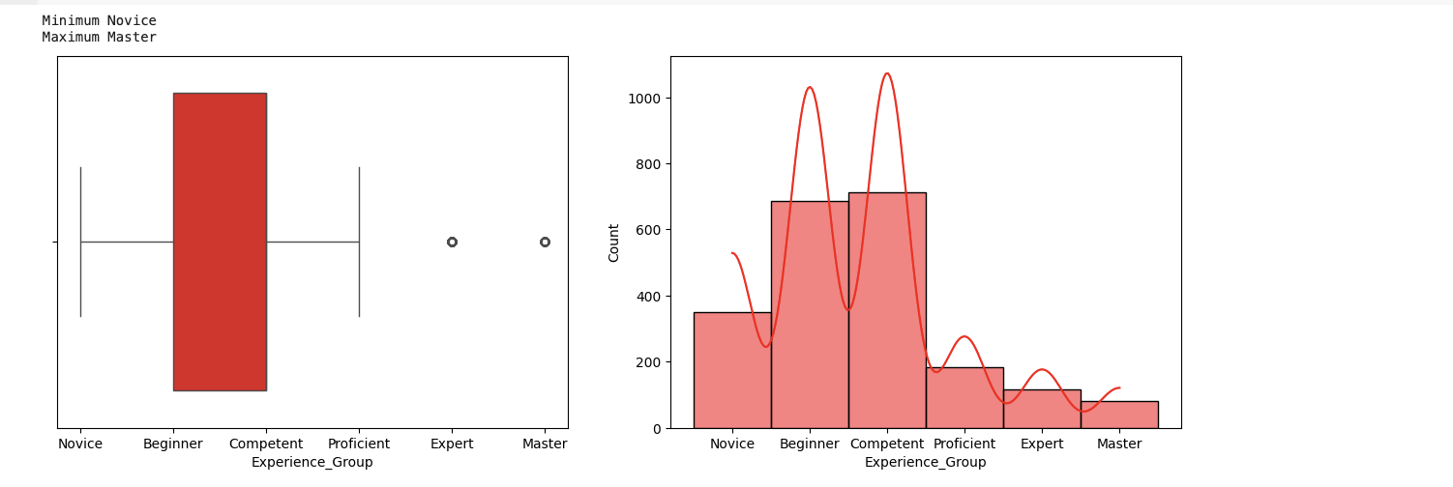

8.Total_Reviews

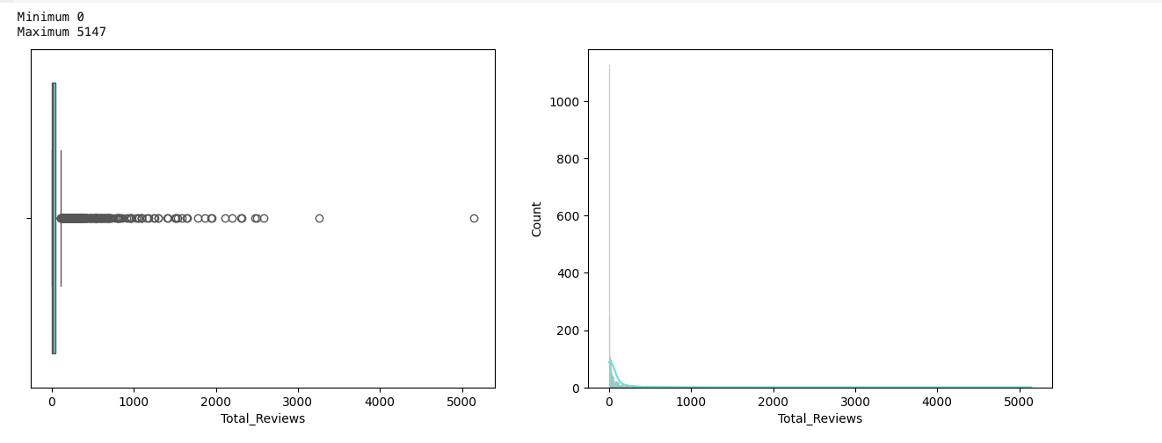

High diversion

most of reviews are 0

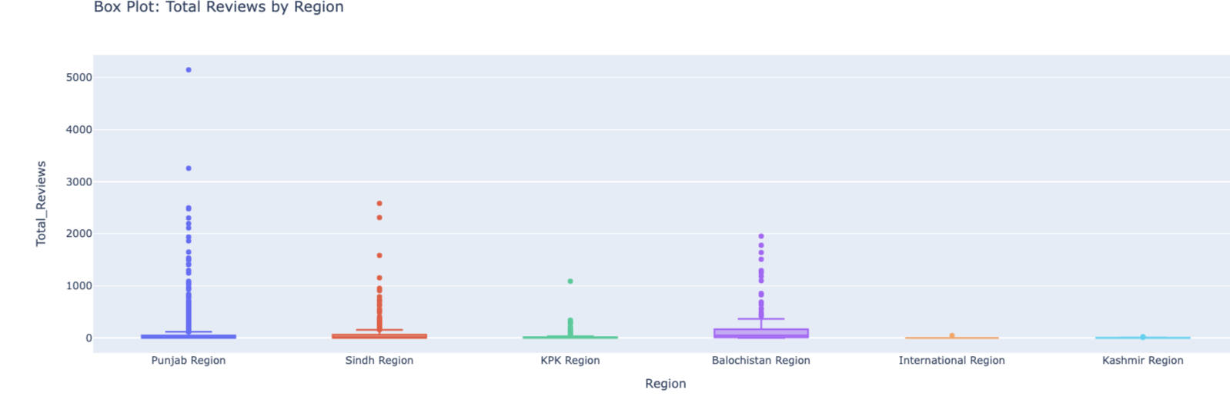

8.1Total_Reviewsfeature engnieering

df['Review_or_Not'] = (df['Total_Reviews'] > 0).astype(int)

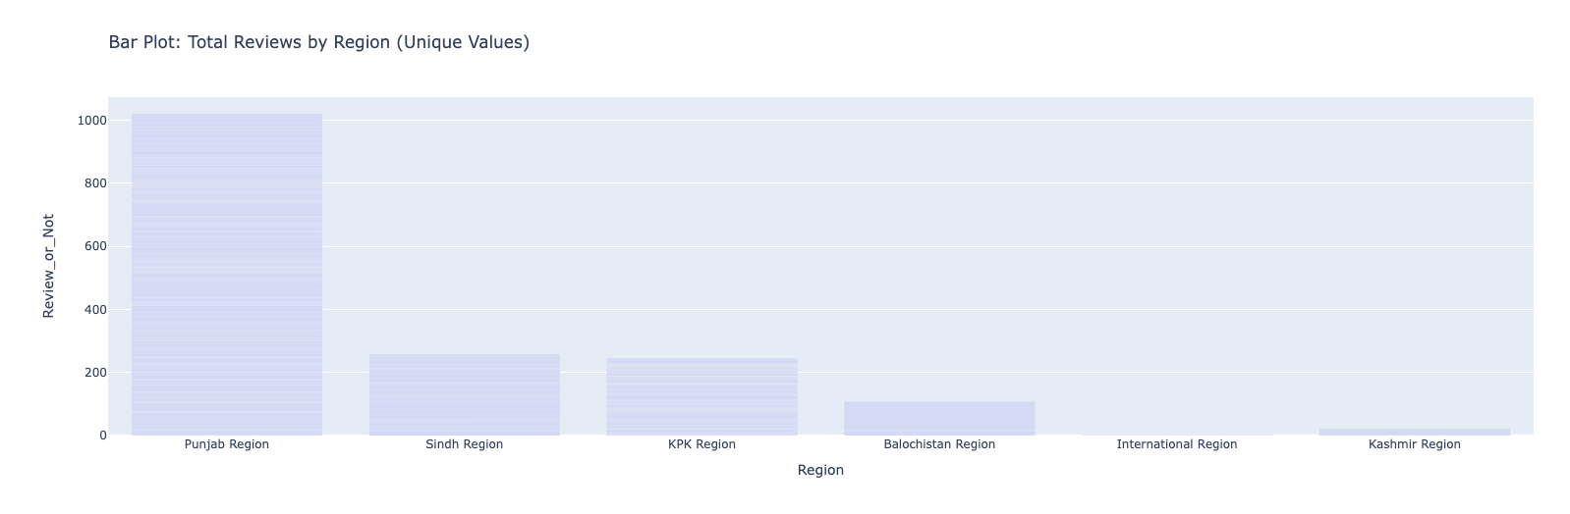

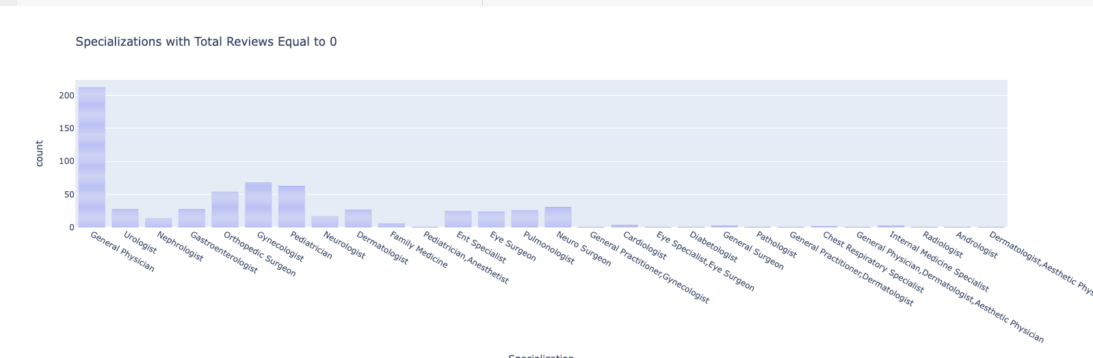

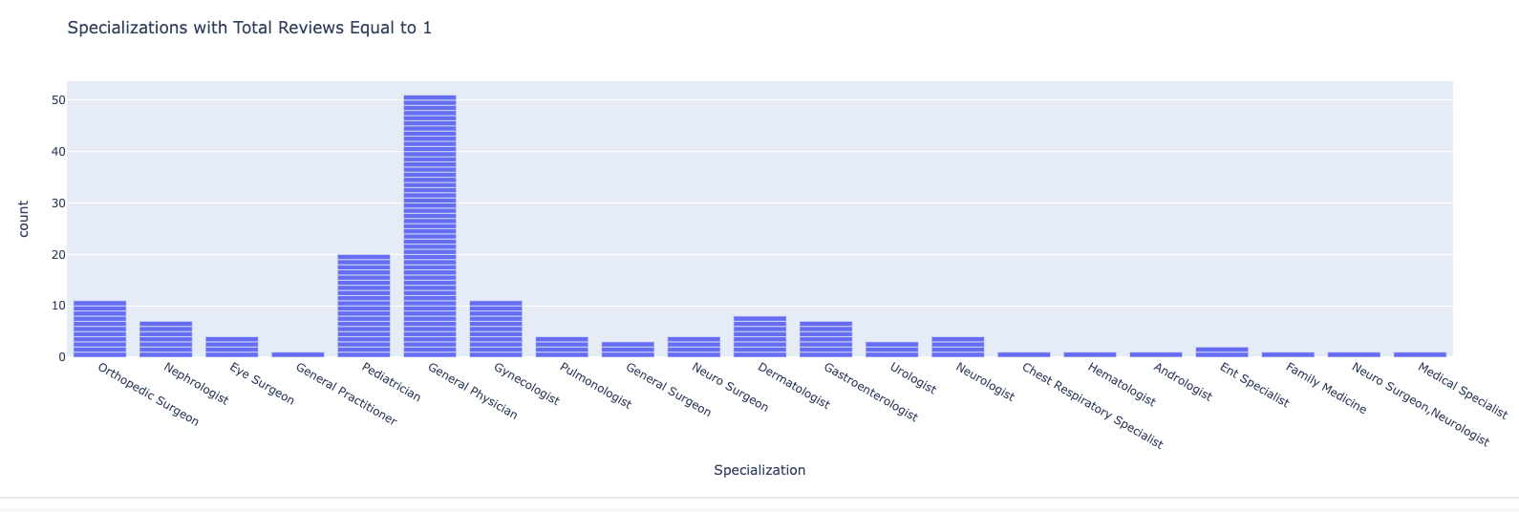

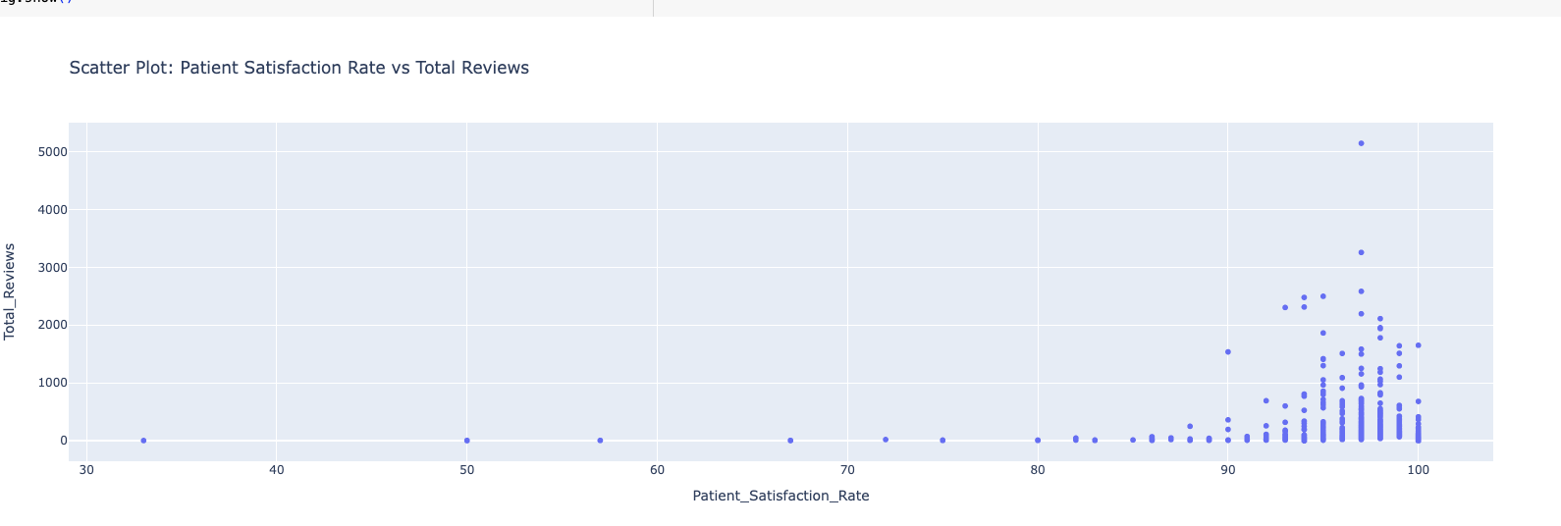

As patient satsfactiion rate increase total reviews increase too

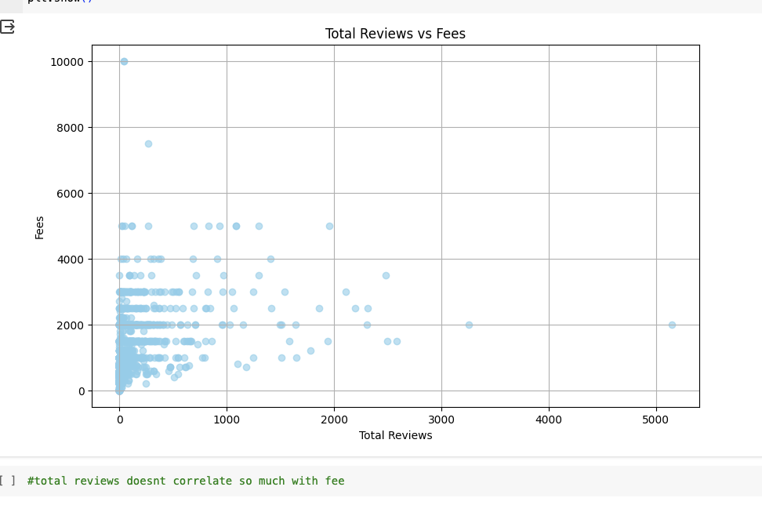

# **9.Patient Satisfaction Rate(%age)**

Number of unique values: 25

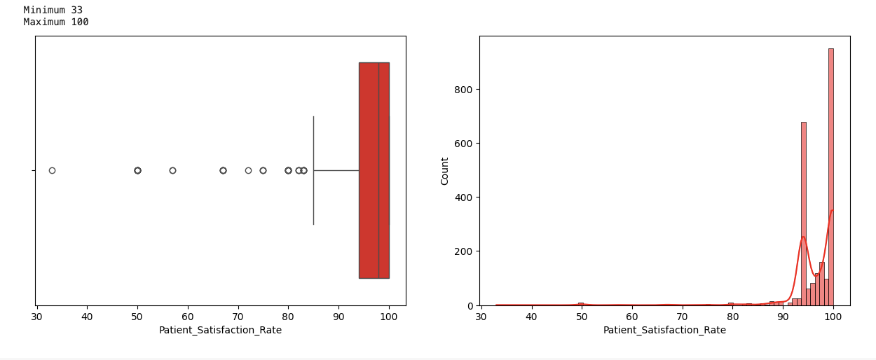

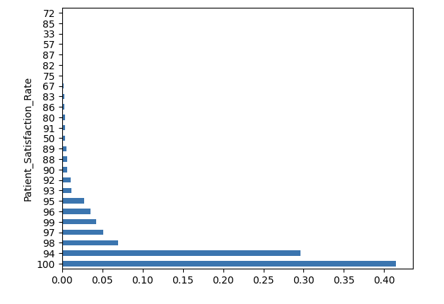

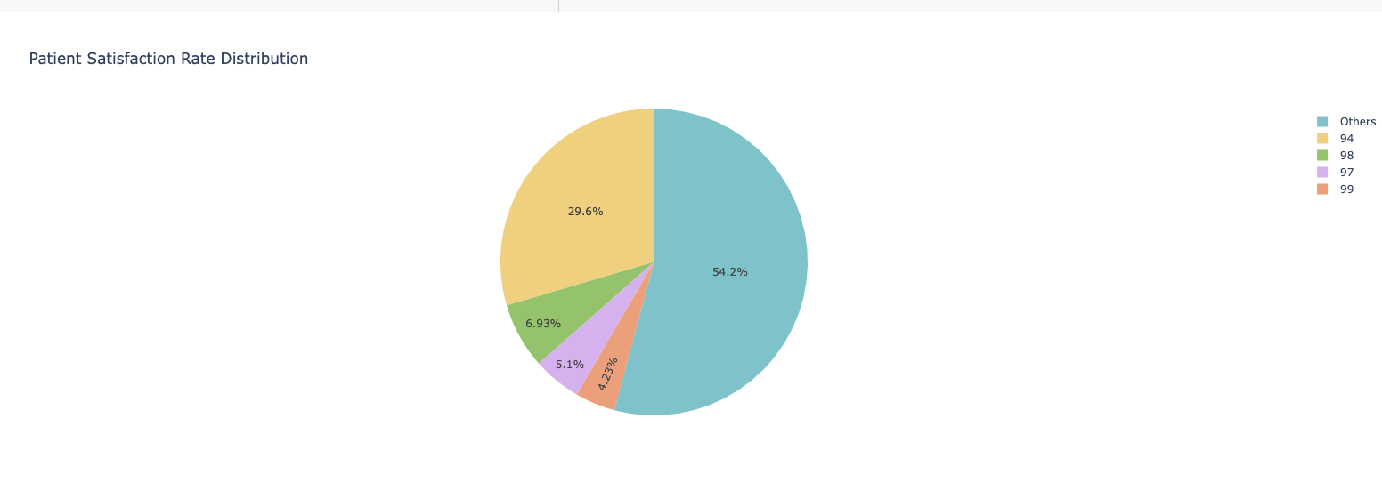

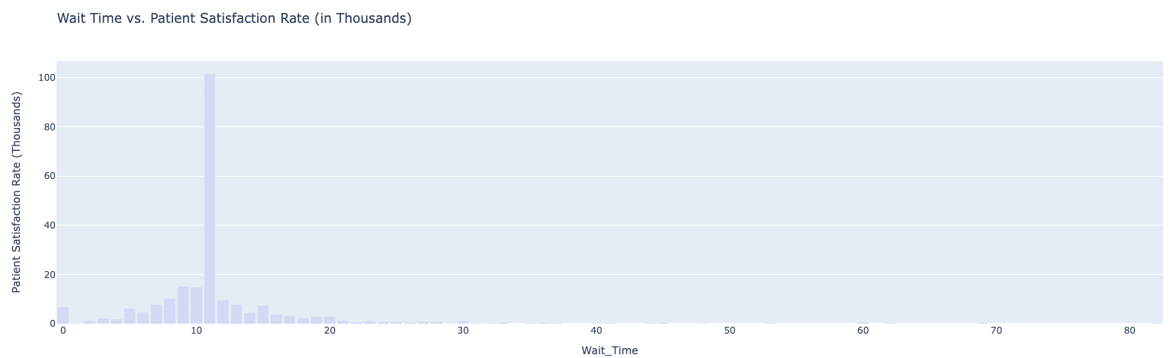

if the waiting time for the dr but the dr is good so it is worth the wait so it doesnt affect

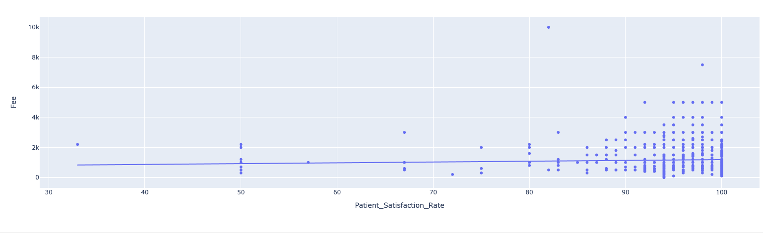

# **10.Avg Time to Patients(min)**

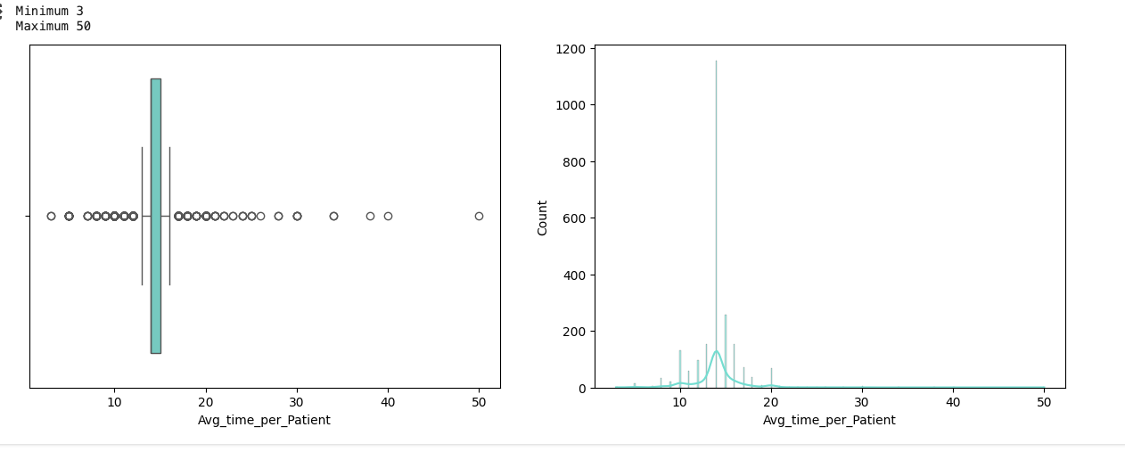

the majority of the patients spend of average less than 15 mins

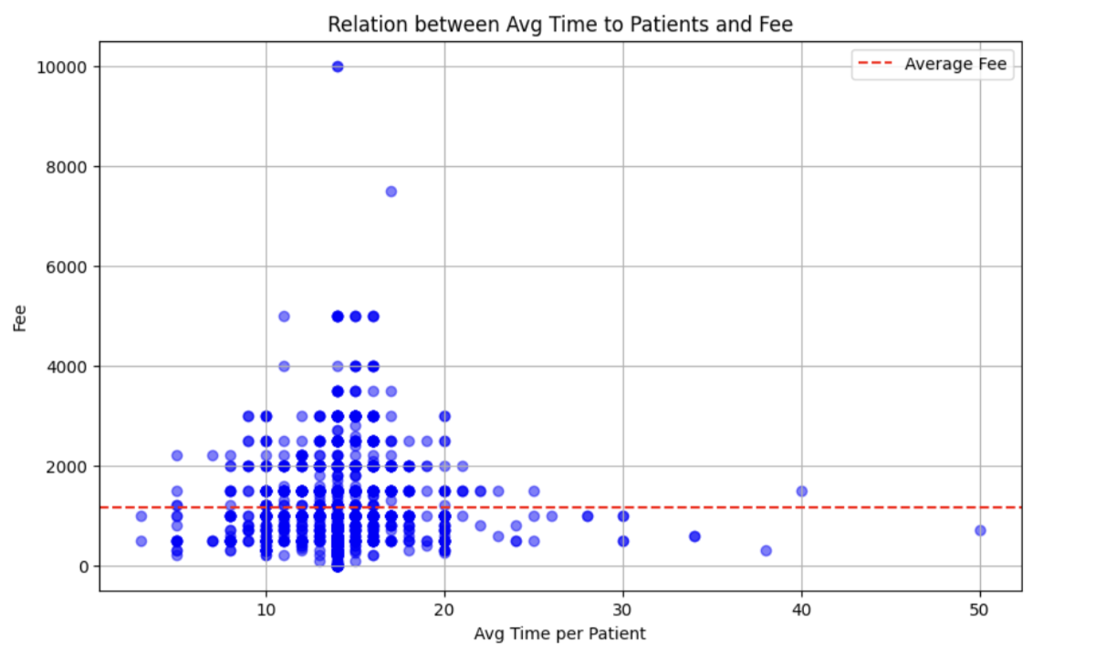

# **11.Wait Time(mins)**

max val = 82

min val = 0

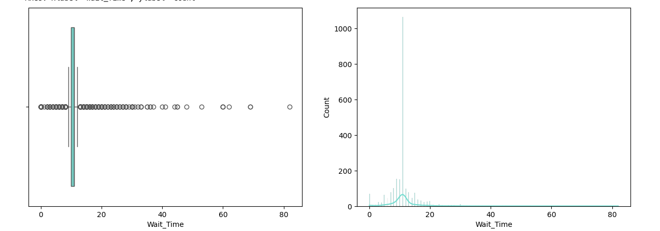

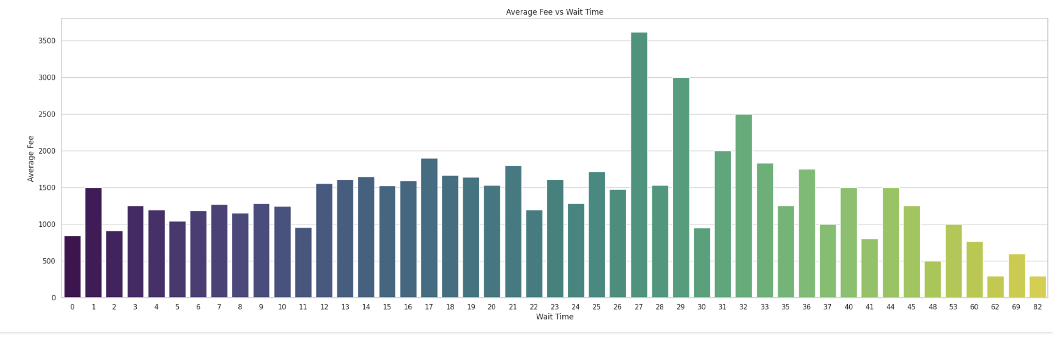

## Feature Engineering (Total Time)

df['Total Time'] = df['Avg_time_per_Patient'] + df['Wait_Time']

12.Feature Scaling

We used minmax Scaler

# **13Fee(Target)**

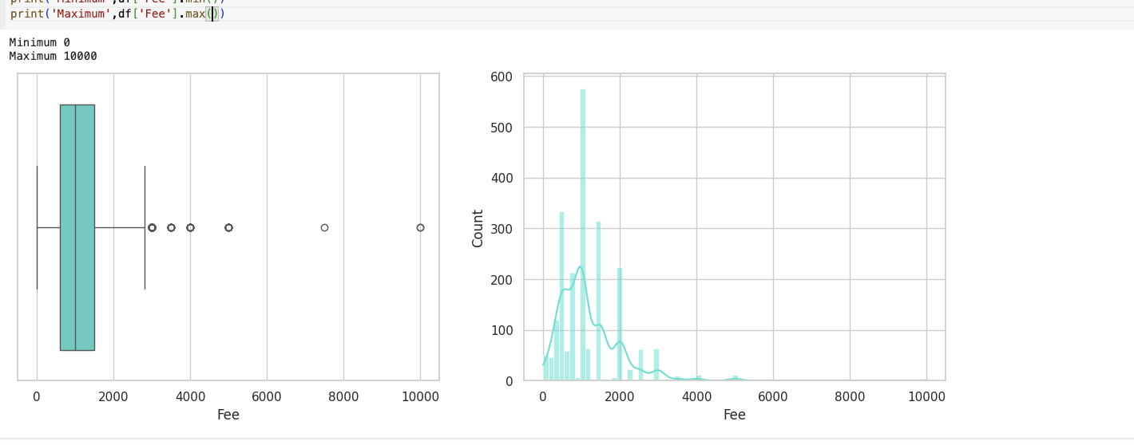

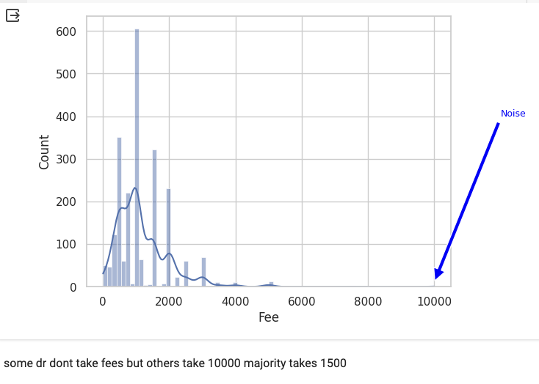

# **14 Preprocessing**



# **14.1 Feature Selection**

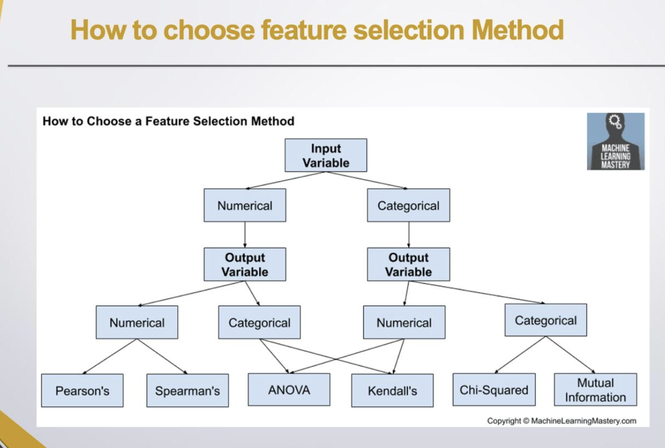

# **14.1.1 Feature Selection (numerical values)**

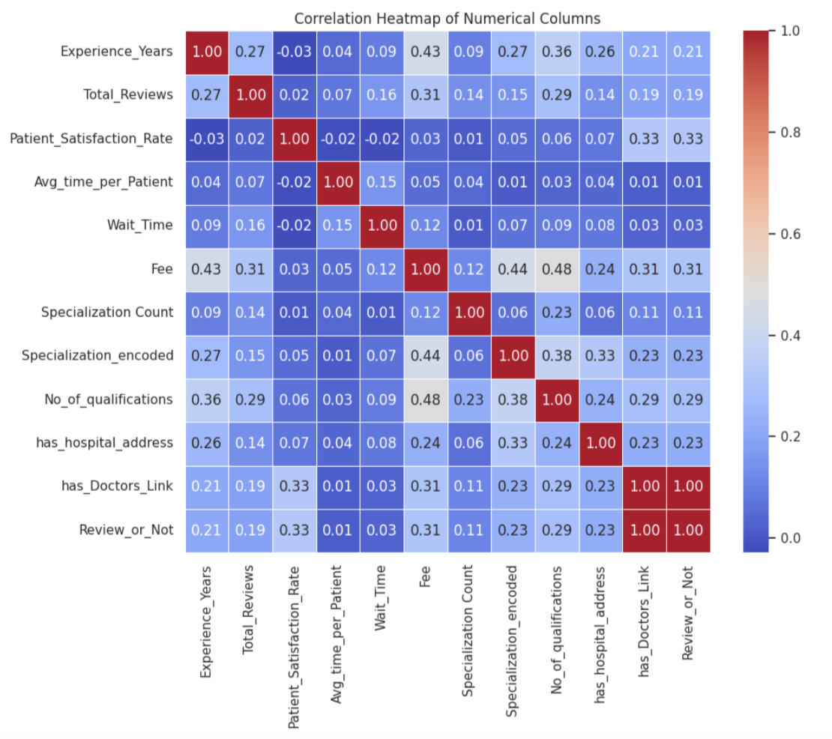

dropped

1.reviews_or_ not the feature Eng. col ass it gives same corr as total reviews

As If two variables are correlated, we can predict one from the other.

2 Patient_Satisfaction_Rate does not add additional information,

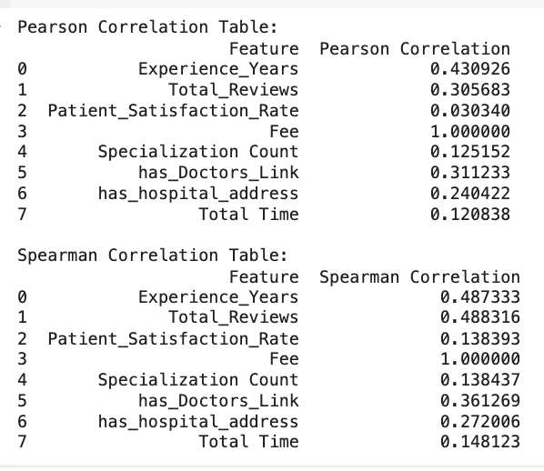

* Experience_Years has a Pearson correlation coefficient of approximately 0.431, indicating a moderate positive linear relationship with Fee
* Total_Reviews has a Pearson correlation coefficient of approximately 0.306, indicating a moderate positive linear relationship with Fee.
* Patient_Satisfaction_Rate has a Pearson correlation coefficient of approximately 0.030, indicating a weak positive linear relationship with Fee.
* Total Time has a Pearson correlation coefficient of approximately 0.121, indicating a very weak positive linear relationship with Fee.

# **14.1.2 Feature Selection (Categorical Data)**

**Cardinality Ratios**

**Is a way to see if we really care about this categorical column**

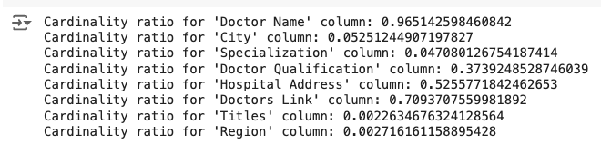

1. **High Cardinality Ratios (> 0.5)**:
   * Columns like 'Doctor Name' and 'Hospital Address' have a high proportion of unique values relative to the dataset size.
   * High cardinality ratios may pose challenges for certain machine learning models, particularly those sensitive to high dimensionality.
2. **Moderate Cardinality Ratios (0.3 - 0.5)**:
   * The 'Doctor Qualification' column falls into this category, indicating a moderate number of unique values compared to the dataset size.
   * These columns may still be useful for encoding into numerical features or for grouping similar categories.
3. **Low Cardinality Ratios (< 0.1)**:
   * Columns such as 'City', 'Specialization', 'Titles', 'Region', 'Experience_Group', and 'Satisfaction_Category' exhibit low cardinality ratios.
   * Such columns are suitable candidates for various encoding techniques, including one-hot encoding, label encoding, or target encoding.

Surly we will drop Doctor Name as CR is almost 1 & Hospital Address, Doctors Link

Concatenated avg time per patient and wait time to total time so will drop too

# **15.1.Feature Scaling (Numerical Data)**

num_cols = ['Experience_Years','Total_Reviews','Total Time']

ideally, we want the skewness to be as close to zero as possible, indicating that the data is symmetrically distributed.

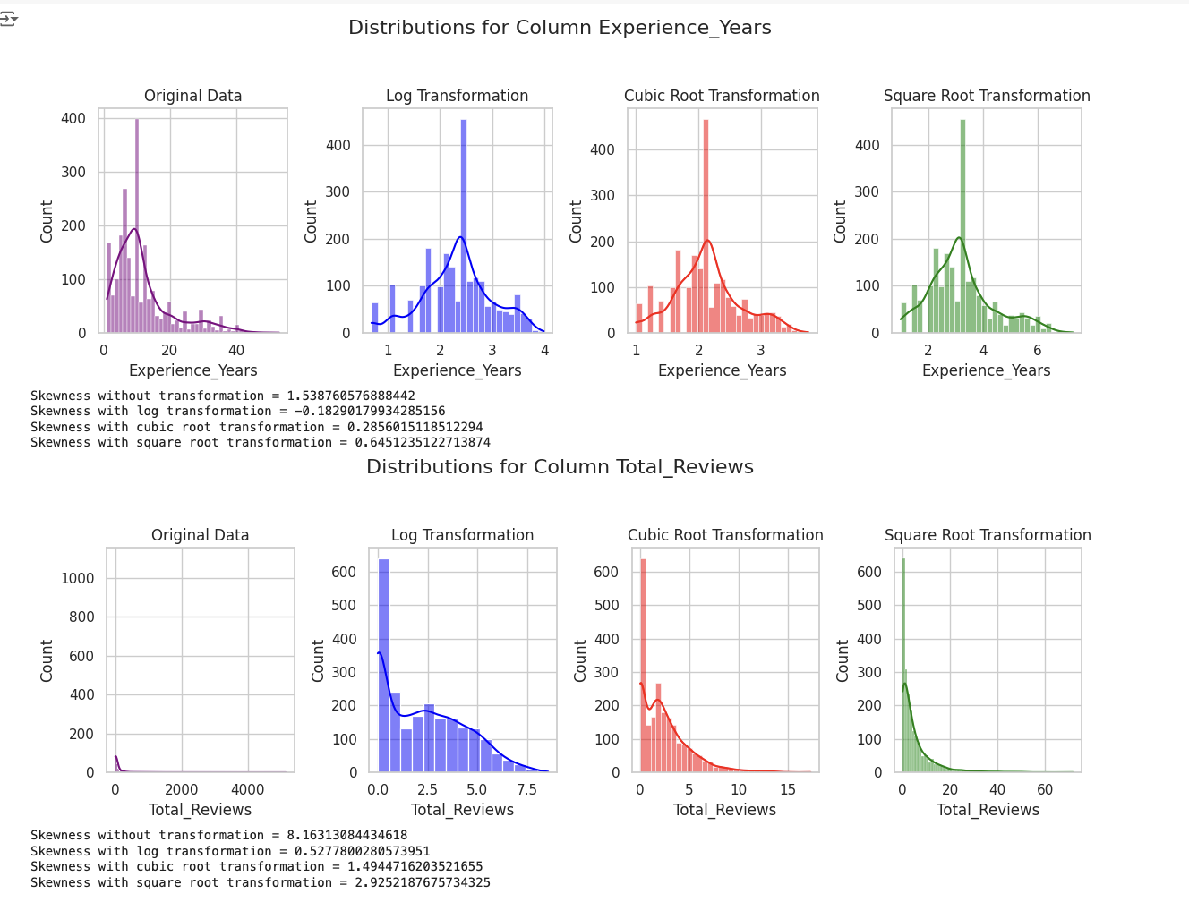

.

* The x-axis represents the quantiles of the theoretical distribution.
* The y-axis represents the quantiles of the dataset's distribution

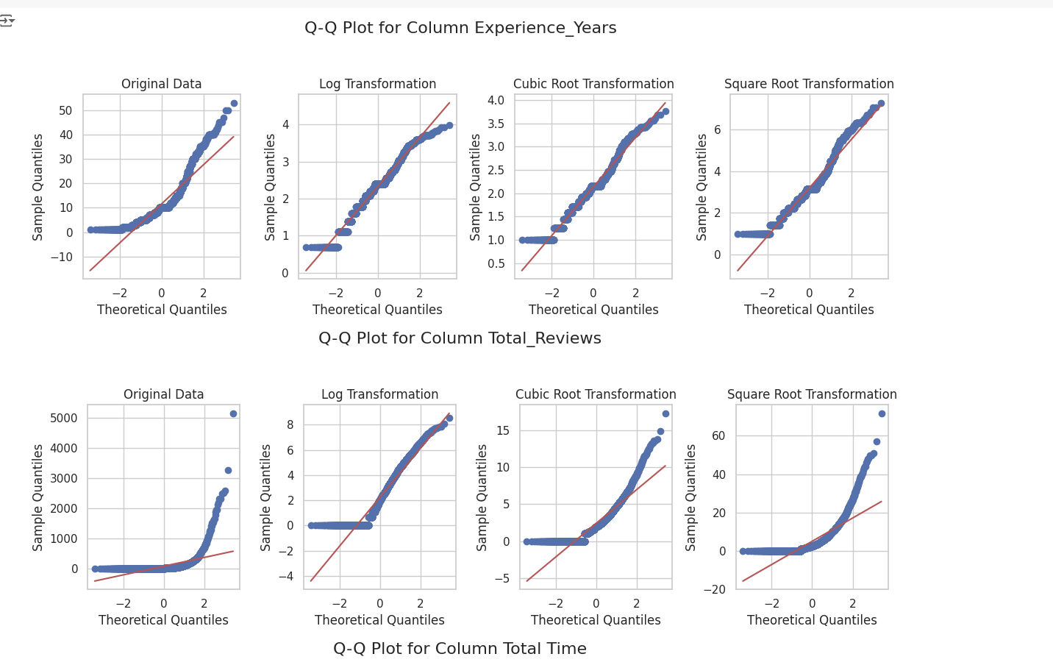

Applied log

otal outliers in column before transformation Experience_Years: 201, Percentage: 9.099139882299683%

----------------------------------------------------------------------------------------------------

Total outliers in column before transformation Total_Reviews: 331, Percentage: 14.984155726573109%

----------------------------------------------------------------------------------------------------

Total outliers in column before transformation Total Time: 569, Percentage: 25.758261656858306%

Total outliers in column aftar log transformation Experience_Years: 69, Percentage: 3.123585332729742%

----------------------------------------------------------------------------------------------------

Total outliers in column aftar log transformation Total_Reviews: 0, Percentage: 0.0%

----------------------------------------------------------------------------------------------------

Total outliers in column aftar log transformation Total Time: 632, Percentage: 28.610230873698505%

16.1Encoding data

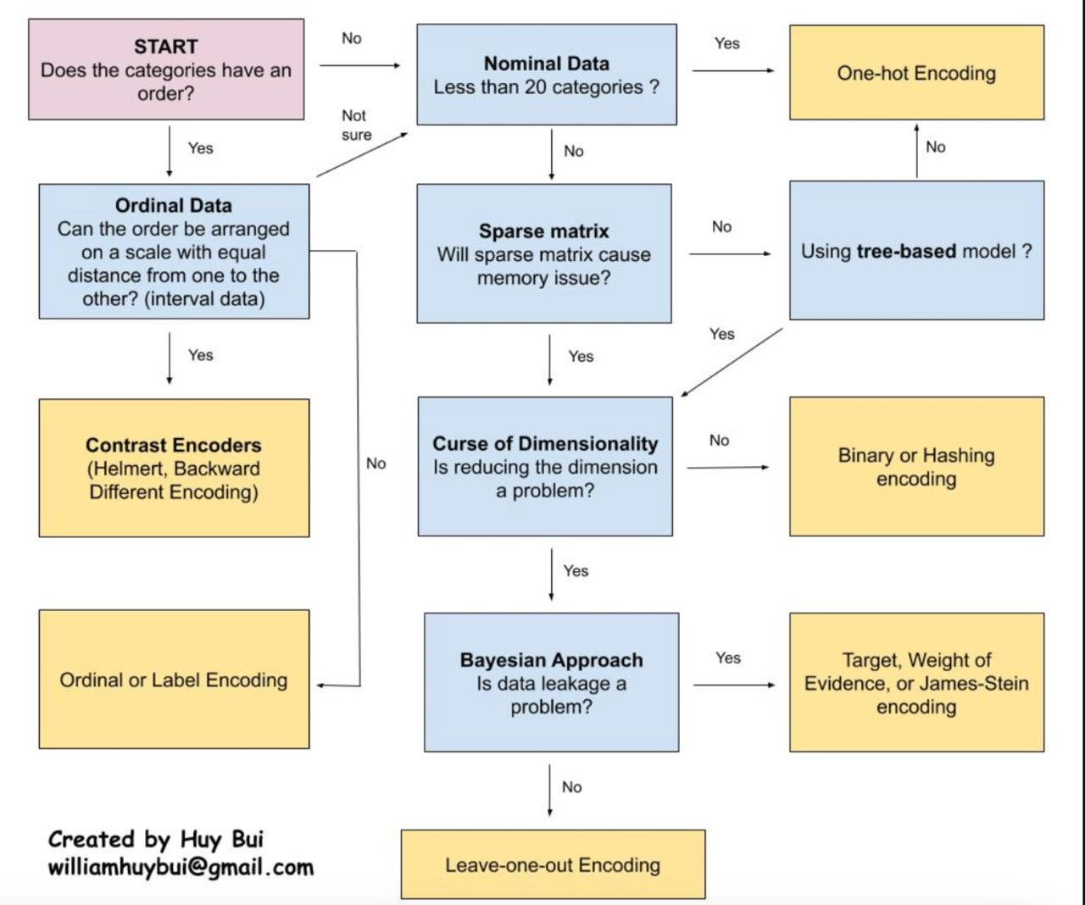

'City', 'Specialization', 'Doctor Qualification', 'Titles'

* Title

Frequency encoder

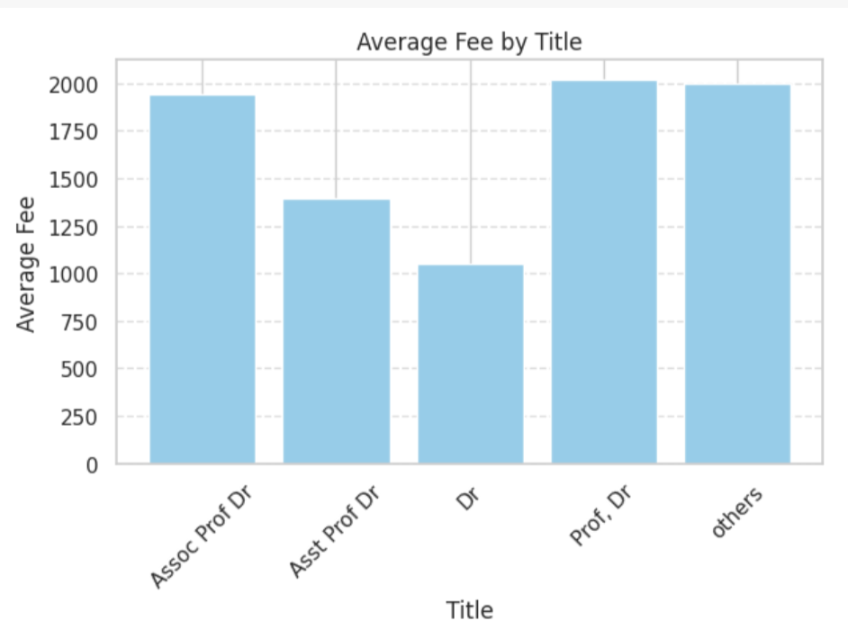

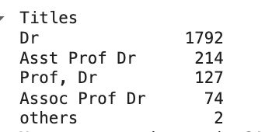

# Target encoding for 'City'

* Specialization encoding

Top 15 Onehot else others

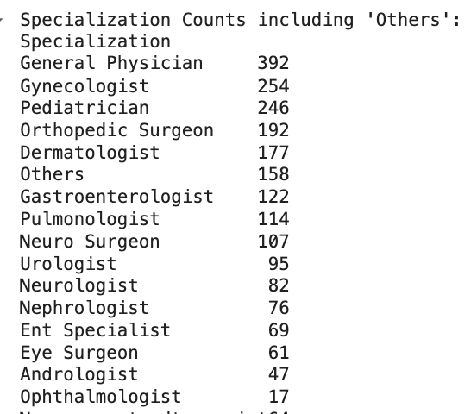

df.drop(['Specialization'], axis=1, inplace=True)

* Doctor_Qualification_encoded

Target encoding

# **17Modeling and feature selection**

Number of columns in the DataFrame: 26

////////////////////////

Used spearsman for feature selection

///////////////////////

Models

Linear Regression

Ridge Regression

Lasso Regression

Random Forest Regressor

AdaBoost Regressor

XGBoost Regressor

Gradient Boosting Regressor

#Models:

1. **Linear Regression**:
   * Basic regression technique assuming a linear relationship between features and target.
   * Simple to interpret and implemen
   * struggled with capturing complex relationships in data.

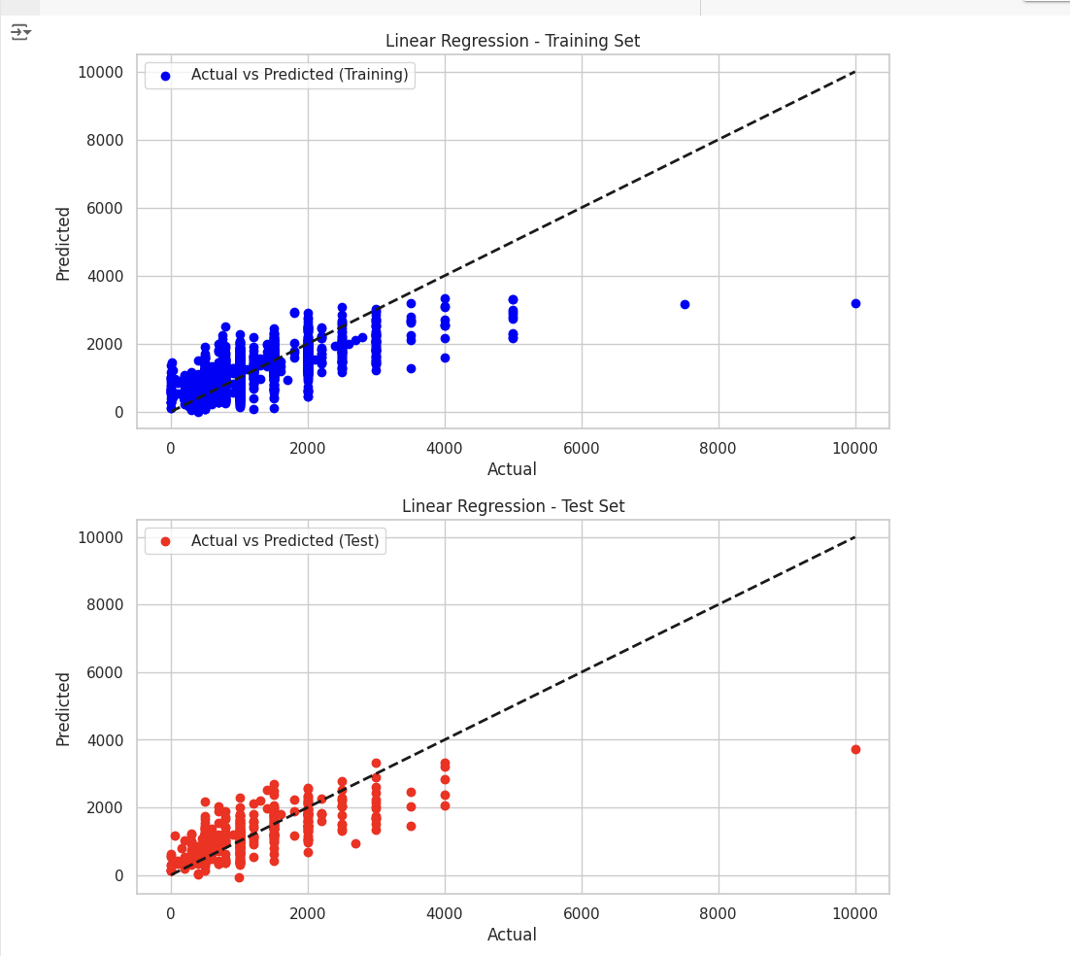

1. **Random Forest Regressor**:
   * Ensemble method averaging predictions of multiple decision trees.
   * Handles both numerical and categorical data well.
   * Robust to overfitting due to ensemble of trees and random feature selection.
   * Can capture non-linear relationships and interactions between features.
2. **Ridge Regression**:
   * Addresses multicollinearity by penalizing large coefficients.
   * Helps mitigate overfitting by adding regularization term to cost function.
3. **Lasso Regression**:
   * Performs feature selection by shrinking less important coefficients to zero.
   * Removes less relevant features from the model.
   * Can be computationally expensive for large datasets.

( we dropped it ,it gives bad accuracy with large amount of time in training )

1. **Gradient Boosting Regressor**:
   * Ensemble method that sequentially combines weak learners (often decision trees).
   * Designed for regression tasks, predicts numeric values.
   * Improves model performance iteratively, focusing on misclassified observations.
2. **AdaBoost Regressor**:
   * Ensemble learning method combining multiple weak learners.
   * Focuses on improving model performance by giving more weight to misclassified observations in each iteration.

7. **XGBoost Regressior:** is a robust and versatile algorithm suitable for regression tasks, especially when dealing with large datasets. Its ability to handle complex relationships, scalability, and interpretability make it a preferred choice across various domains and applications.

**# Best Hyperparameters**

1. **Linear Regression**: No hyperparameters to tune
2. **Ridge Regression**: Hyperparameter: **alpha** ->Represents the regularization strength.
3. **Lasso Regression**: Hyperparameter: **alpha->** Similar to Ridge regression However, Lasso also tends to shrink some coefficients all the way to zero, effectively performing feature selection.
4. **Random Forest Regressor**:

Hyperparameters: **max_depth**, **min_samples_split**, **n_estimators**

**max_depth**: Maximum depth of the trees in the forest.

**min_samples_split**: Minimum number of samples required to split an internal node.

**n_estimators**: Number of trees in the forest.

1. **AdaBoost Regressor**: Hyperparameters: **learning_rate**, **n_estimators**

**learning_rate**: Controls the contribution of each weak learner to the final prediction.**n_estimators**: Number of weak learners (decision trees) to train sequentially.

1. **XGBoost Regressor**: Hyperparameters: **learning_rate**, **max_depth**, **n_estimators**

**learning_rate**: Also known as the shrinkage parameter, controls the step size during optimization.

**max_depth**: Maximum depth of the trees in the boosting process.

**n_estimators**: Number of boosting rounds (iterations).

1. **Gradient Boosting Regressor:** Hyperparameters: **learning_rate**, **max_depth**, **n_stimators**

**learning_rate:** Represents the step size at each iteration

**max_depth**: Maximum depth of the trees in the boosting process.

**n_estimators**: Number of boosting rounds (iterations).

**Used**

1.randomized search cross-validation

**2.** We define a dictionary **models** that contains the names of the models as keys and their corresponding sklearn model objects as values. Each model has its own hyperparameters to optimize using randomized search.

### 3 **Model Evaluation Loop**

For each model, we perform the following steps:

1. Define hyperparameter distributions based on the model type.
2. Perform randomized search cross-validation to find the best hyperparameters.
3. Train the best model on the training data.
4. Evaluate the model on both training and testing data.
5. Store the results in dictionaries (**train_results** and **test_results**).

**4 Spearman Correlation Coefficients**

**We calculate the Spearman correlation coefficients between each feature and the target variable ('Fee').**

### 4Feature Selection

We select the top k features based on their correlation coefficients with the target variable.

**5** **Cross-Validation**: Cross-validation is a technique used to assess how well a model generalizes to new,( folds)

1. 6 **Select Best Hyperparameters**: Identify the hyperparameter combination with the best performance based on the evaluation metric.

**n_jobs** parameter in the **RandomizedSearchCV**

make use of all available CPU cores to perform the randomized search in parallel, significantly speeding up the process

